**A**

**PROJECT REPORT**

**ON**

**IOT BASED HEALTH MONITORING SYSTEM**

SUBMITTED IN PARTIAL FULFILLMENT OF THE REQUIREMENT FOR

THE AWARD OF DIPLOMA

**IN**

**ELECTRONICS & COMMUNICATION ENGINEERING.**

SUBMITTED BY

**MUKIRI SUNNY BABU**

19253-EC-238

**UNDER THE GUIDANCE OF**

**K. MOUNIKA** (Lecturer)

Department of Electronics & Communication

**Engineering VNRVJIET**



**2nd SHIFT POLYTECHNIC**

**DIPLOMA IN ELECTRONICS & COMMUNICATION ENGINEERING**

**VALLURUPALLI NAGESWARA RAO**

VIGNANA JYOTHI INSTITUTE OF ENGINEERING AND TECHNOLOGY

VIGNANA JYOTHI NAGAR, BACHUPALLY, NIZAMPET (S. O),

**HYDERABAD - 500 090**

**2021– 2022.**

**A**

**PROJECT REPORT**

**ON**

**IOT BASED HEALTH MONITORING SYSTEM**

SUBMITTED IN PARTIAL FULFILLMENT OF THE REQUIREMENT FOR

THE AWARD OF DIPLOMA

**IN**

**ELECTRONICS & COMMUNICATION ENGINEERING.**

**SUBMITTED BY**

19253-EC-243 T. RAJEEV

19253-EC-224 U. SAI KUMAR

19253-EC-228 N. KARTHIK

19253-EC-238 M. SUNNY BABU

19253-EC-253 K. PALLAVI

**UNDER THE GUIDANCE OF**

**K. MOUNIKA** (Lecturer)

Department of Electronics & Communication

**Engineering VNRVJIET**



**2nd SHIFT POLYTECHNIC**

**DIPLOMA IN ELECTRONICS & COMMUNICATION ENGINEERING**

**VALLURUPALLI NAGESWARA RAO**

VIGNANA JYOTHI INSTITUTE OF ENGINEERING AND TECHNOLOGY

VIGNANA JYOTHI NAGAR, BACHUPALLY, NIZAMPET (S. O),

**HYDERABAD - 500 090**

**2021– 2022.**

**2nd SHIFT POLYTECHNIC**

**VALLURUPALLI NAGESWARA RAO VIGNANA JYOTHI**

**INSTITUTE OF ENGINEERING & TECHNOLOGY**



**CERTIFICATE**

This is to certify that the project report entitled **“IOT BASED HEALTH MONITORING SYSTEM”** has been carried out at VNR VJIET, Hyderabad and submitted by the following students.

19253-EC-243 T. RAJEEV

19253-EC-224 U. SAI KUMAR

19253-EC-228 N. KARTHIK

19253-EC-238 M. SUNNY BABU

19253-EC-253 K. PALLAVI

In partial fulfilment of the requirements for the award of **Diploma in Electronics &Communication Engineering** to **State Board of Technical Education and Training, Telangana** at **VNR Vignana Jyothi Institute of Engineering & Technology** during the period of 2021-2022, he/she carried out a bonafide work under the guidance and supervision of the under signed. The results embodied in this project report have not been submitted to any another University or institute for the award of any Degree.

**K. MOUNIKA Dr. S. RAJENDRA PRASAD**

Lecturer, Head of the Department,

Electronics & Communication Engineering Electronics & Communication Engineering,

VNR VJIET VNR VJIET

**APPROVAL CERTIFICATE**

Viva–Voice examination conducted for the dissertation work entitled **“IOT BASED HEALTH MONITORING SYSTEM**”.

19253-EC-243 T. RAJEEV

19253-EC-224 U. SAI KUMAR

19253-EC-228 N. KARTHIK

19253-EC-238 M. SUNNY BABU

19253-EC-253 K. PALLAVI

is conducted on the work is approved for the award of degree of Diploma in **Electronics& Communication Engineering**.

**Internal Examiner** **External Examiner**

**ACKNOWLEDGEMENT**

Our sincere thanks to **Mrs K. MOUNIKA**, Department of Electronics and Communication Engineering, 2nd SHIFT POLYTECHNIC, VNR VJIET, who motivated us during project work, guiding us throughout inspire of her schedules and commitments.

Our Sincere thanks to **Dr. S. RAJENDRA PRASAD**, Head of the Department, Electronics and Communication Engineering, VNR VJIET & all the faculty of the Department for the encouragement and guidance provided.

We extend our sincere thanks to **Dr. B. SATYANARAYANA**,Vice Principal, 2nd polytechnic, VNR VJIET, Hyderabad, for shift his help & co-operation in providing support for project work.

A special note of thanks to **Dr. C. D. NAIDU**, Principal, VNRVJIET and management of VNRVJIET for providing facilities for project work.

We sincerely thank all of them who have helped us either directly or indirectly during the completion of the project tenure.

19253-EC-243 T. RAJEEV

19253-EC-224 U. SAI KUMAR

19253-EC-228 N. KARTHIK

19253-EC-238 M. SUNNY BABU

19253-EC-253 K. PALLAVI

**Place:** Bachupally**,** Hyderabad

**Date:**

**DECLARATION**

We do declare that this work entitled” **“IOT BASED HEALTH MONITORING SYSTEM”** submitted in the department of Electronics and communication engineering by us to **VNR VJIET**, Bachupally in partial fulfilment of the requirement for the degree of diploma in electronic communication and engineering is a bonafide record of our own work carried out under the supervision of **Mrs K. MOUNIKA**.

Also, we declare that the matter embodied in this thesis has not been submitted by us in full or any part thereof for the award of any other degree/diploma in this institute or any other institute or university previously.

MUKIRI SUNNY BABU

( 19253-EC-238 )

**Place:** Bachupally**,** Hyderabad

**Date:**

**ABSTRACT**

Currently, the COVID 19 pandemic is one of the global issues faced by health organizations. As of February 2022, the total number of people worldwide confirmed to have been infected with COVID is more than 399 million people. As the increasing technology the ongoing COVID 19 pandemic, IOT (Internet of Things) based health monitoring system that is a real time health monitoring systems are potentially immensely beneficial for COVID-19 patients.

This study presents an IOT based system that is a real time health monitoring system utilizing measured values of body temperature, pulse rate, oxygen saturation of the patient, ECG reading. Which are mostly measurements required for critical care. It is an Arduino based system which is easy to code and as well as an GSM module for connecting and sending messages to the doctor as also the patients relatives or guardians. This helps in preventing the spread of the COVID-19 in turn helping world fight against spread of CORONA VIRUS.

**CONTENTS**

|  |  |  |  |  |
| --- | --- | --- | --- | --- |
| **CHAPTER NO.** | **CHAPTER NAME** | | | **PAGE NO.** |
| **Chapter 1** | **Introduction** | | | 1 |
| **Chapter 2** | **Components Description** | | |  |
|  | **2.1** | **Arduino Mega** | |  |
|  | 2.1.1 | Introduction | | 3 |
|  | 2.1.2 | Pin description | | 4 |
|  | 2.1.3 | Specifications | | 6 |
|  | 2.1.4 | Advantages | | 6 |
|  | 2.1.5 | Disadvantages | | 7 |
|  | 2.1.6 | Applications | | 7 |
|  | **2.2** | **NodeMCU - ESP8266** | |  |
|  | 2.2.1 | Introduction | | 8 |
|  | 2.2.2 | Pin description | | 9 |
|  | 2.2.3 | Components on NodeMCU | | 10 |
|  | 2.2.4 | Specifications and Features | | 10 |
|  | 2.2.5 | Applications | | 11 |
|  | **2.3** | **GSM Module - SIM800A** | |  |
|  | 2.3.1 | Introduction | | 12 |
|  | 2.3.2 | Power Supply for GY906 | | 12 |
|  | 2.3.3 | Pin description | | 13 |
|  | 2.3.4 | Working | | 14 |
|  | 2.3.5 | Specifications | | 15 |
|  | 2.3.6 | Advantages | | 15 |
|  | 2.3.7 | Disadvantages | | 16 |
|  | 2.3.8 | Applications | | 16 |
|  | **2.4** | **Pulse oxygen sensor – MAX30100** | |  |
|  | 2.4.1 | Introduction | | 17 |
|  | 2.4.2 | Hardware description | | 17 |
|  | 2.4.3 | Working | | 20 |
|  | 2.4.4 | Functional block diagram | | 22 |
|  | 2.4.5 | Interfacing MAX30100 to arduino | | 22 |
|  | 2.4.6 | Specifications | | 23 |
|  | 2.4.7 | Advantages | | 23 |
|  | 2.4.8 | Applications | | 24 |
|  | **2.5** | **Temperature sensor – GY906** | |  |
|  | 2.5.1 | Introduction | | 25 |
|  | 2.5.2 | Hardware overview | | 25 |
|  | 2.5.3 | Working | | 27 |
|  | 2.5.4 | Pin description | | 29 |
|  | 2.5.5 | Interfacing GY906 to arduino | | 29 |
|  | 2.5.3 | Specifications | | 30 |
|  | 2.5.4 | Applications | | 30 |
|  | **2.6** | **ECG sensor – AD8232** | |  |
|  | 2.6.1 | Introduction | | 31 |
|  | 2.6.2 | Working | | 32 |
|  | 2.6.3 | Pin description | | 33 |
|  | 2.6.4 | Interface of ecg sensor with arduino | | 33 |
|  | 2.6.5 | AD8232 sensor placement on body | | 35 |
|  | 2.6.6 | Specifications | | 35 |
|  | 2.6.7 | Applications | | 36 |
|  | **2.7** | **Display – LCD 16x2** | |  |
|  | 2.7.1 | Introduction | | 37 |
|  | 2.7.2 | Construction | | 38 |
|  | 2.7.3 | Working | | 38 |
|  | 2.7.4 | Pin description | | 40 |
|  | 2.7.5 | Interfacing lcd to arduino | | 41 |
|  | 2.7.6 | Specifications | | 42 |
|  | 2.7.7 | Advantages | | 42 |
|  | 2.7.8 | Disadvantages | | 42 |
|  | 2.7.9 | Applications | | 42 |
|  | **2.8** | **Buzzer** | |  |
|  | 2.8.1 | Introduction | | 43 |
|  | 2.8.2 | Types | | 43 |
|  | 2.8.3 | Piezo electric buzzer | | 43 |
|  | 2.8.4 | Working | | 44 |
|  | 2.8.5 | Pin description | | 45 |
|  | 2.8.6 | Specifications | | 45 |
|  | 2.8.7 | Applications | | 46 |
|  | **2.9** | **Push button switch** | |  |
|  | 2.9.1 | Introduction | | 47 |
|  | 2.9.2 | Working | | 47 |
|  | 2.9.3 | Types | | 48 |
|  | 2.9.4 | Pin description | | 48 |
|  | 2.9.5 | Specifications | | 49 |
|  | 2.9.6 | Features | | 49 |
|  | 2.9.7 | Applications | | 49 |
|  | **2.10** | **Breadboard** | |  |
|  | 2.10.1 | Introduction | | 50 |
|  | 2.10.2 | Types | | 50 |
|  | 2.10.3 | Specifications | | 52 |
|  | 2.10.4 | Advantages | | 52 |
|  | 2.10.5 | Disadvantages | | 52 |
|  | 2.10.6 | Safety tips for breadboard | | 53 |
|  | 2.10.4 | Applications | | 53 |
|  | **2.11** | **9v Battery** | |  |
|  | 2.11.1 | Description | | 54 |
|  | 2.11.2 | About battery connector | | 55 |
|  | 2.11.3 | Specifications | | 55 |
|  | 2.11.4 | Safety precautions | | 56 |
|  | 2.11.5 | Features | | 56 |
|  | **2.12** | **Jumper wires** | |  |
|  | 2.12.1 | Description | | 57 |
|  | 2.12.2 | Types | | 58 |
|  | 2.12.3 | Advantages | | 59 |
|  | **2.13** | **I2C interface for LCD** | |  |
|  | 2.13.1 | Introduction | | 60 |
|  | 2.13.2 | Pin introduction | | 60 |
|  | 2.13.3 | Interfacing lcd with arduino | | 61 |
|  | 2.13.4 | Applications | | 61 |
| **Chapter 3** | **Software description** | | |  |
|  | **3.1** | | **Arduino Software** |  |
|  | 3.1.1 | | Installing Arduino IDE | 62 |
|  | 3.1.2 | | Creating New Project | 63 |
|  | 3.1.3 | | Adding the esp path to arduino preferences | 63 |
|  | 3.1.4 | | Downloading the ESP8266 Board | 64 |
|  | 3.1.5 | | Board selection in Arduino IDE | 64 |
|  | 3.1.6 | | Port selection in Arduino IDE | 65 |
|  | 3.1.7 | | Compiling, saving and uploading the program | 65 |
|  | **3.2** | | **Thinger.io** |  |
|  | 3.2.1 | | Introduction | 66 |
|  | 3.2.2 | | Creating an account in thinger | 67 |
|  | 3.2.3 | | Creating a device in thinger | 67 |
|  | 3.2.4 | | Creating a dashboard in thinger | 68 |
| **Chapter 4** | **About Project** | | |  |
|  | 4.1 | | Block diagram | 70 |
|  | 4.2 | | Circuit diagram | 73 |
| **Chapter 5** | **Result** | | | 75 |
| **Chapter 6** | **Advantages and applications** | | |  |
|  | 6.1 | | Advantages | 76 |
|  | 6.2 | | Applications | 76 |
|  | 6.3 | | Conclusion | 77 |
|  | 6.4 | | Future scope | 78 |
| **APPENDIX** | **Program of Arduino mega** | | | 79 |
|  | **Program of ESP8266** | | | 85 |
| **REFERENCES** | | | | 88 |

**LIST OF THE FIGURES**

|  |  |  |
| --- | --- | --- |
| **Figure no.** | **Figure name** | **Page no.** |
|  | Arduino mega | 3 |
|  | Component description of arduino | 4 |
|  | Pin description of arduino | 5 |
|  | NodeMCU – ESP8266 | 8 |
|  | Pin description of NodeMCU | 9 |
|  | Components of NodeMCU | 10 |
|  | GSM Module – SIM800A | 12 |
|  | Pin configuration of GSM Module | 13 |
|  | Working of GSM Module | 14 |
|  | Pulse oxygen sensor - MAX30100 | 17 |
|  | Sensor on Max30100 | 17 |
|  | Power requirement of Max30100 | 18 |
|  | Interrupt in Max30100 | 19 |
|  | Working of Max30100 | 20 |
|  | Heart rate measurement in max30100 | 21 |
|  | SPO2 measurement in Max30100 | 21 |
|  | Functional block diagram of Max30100 | 22 |
|  | Interfacing of Max30100 with Microcontroller | 22 |
|  | GY906 | 25 |
|  | Hardware description of GY906 | 26 |
|  | Optical filter on GY906 | 26 |
|  | Functional block diagram of GY906 | 27 |
|  | Field of view of GY906 | 28 |
|  | Pin description of GY906 | 29 |
|  | Interfacing GY906 to arduino | 30 |
|  | ECG graph | 31 |
|  | ECG sensor | 32 |
|  | Pin description of AD8232 | 33 |
|  | Interfacing of AD8232 with arduino | 34 |
|  | AD8232 placement on Human body | 35 |
|  | LCD 16x2 | 37 |
|  | Text on LCD | 37 |
|  | Construction of LCD | 38 |
|  | Working of LCD | 39 |
|  | Pin description of LCD | 40 |
|  | Interfacing of LCD to arduino | 41 |
|  | Piezo electric buzzer | 43 |
|  | Working of buzzer | 44 |
|  | Structure of buzzer | 44 |
|  | Pin description of buzzer | 45 |
|  | Push button switch | 47 |
|  | Closed switch | 48 |
|  | Open switch | 48 |
|  | Pin description of switch | 48 |
|  | Breadboard | 50 |
|  | Solderless Breadboard | 51 |
|  | Solderable Breadboard | 52 |
|  | 9v battery | 54 |
|  | Symbol of battery | 54 |
|  | Battery connector | 55 |
|  | Jumper wires | 57 |
|  | Types of Jumper wires | 58 |
|  | I2C module for LCD | 60 |
|  | Pin description of I2C | 60 |
|  | Interfacing I2C module with arduino | 61 |
|  | Installing Arduino IDE - I | 62 |
|  | Installing Arduino IDE – II | 62 |
|  | Creating new project on arduino ide | 63 |
|  | Adding esp path to preferences in arduino ide | 63 |
|  | Downloading the board in arduino ide | 64 |
|  | Board selection on arduino ide | 64 |
|  | Port selection in arduino ide | 65 |
|  | Basic tools in arduino ide | 65 |
|  | Thinger.io | 66 |
|  | Creating an account in thinger | 67 |
|  | Creating a device in thinger | 67 |
|  | Showing list of devices | 68 |
|  | Dashboard of thinger | 68 |
|  | Dashboard showing real time values in thinger | 69 |
|  | Block diagram of project | 70 |
|  | Circuit diagram of project | 73 |
|  | Result of project | 75 |

**LIST OF TABLES**

|  |  |  |
| --- | --- | --- |
| **TABLE NO.** | **TABLE NAME** | **PAGE NO.** |
| 1 | Specifications of Arduino | 6 |
| 2 | Pin description of NodeMCU | 9 |
| 3 | Pin description of MAX30100 | 20 |
| 4 | Specifications of MAX30100 | 23 |
| 5 | Pin description of GY906s | 29 |
| 6 | Specifications of GY906 | 30 |
| 7 | Pin description of AD8232 | 34 |
| 8 | Pin description of LCD 16X2 | 40 |
| 9 | Pin description of Buzzer | 45 |
| 10 | Pin description of Push button switch | 48 |
| 11 | Specifications of battery | 55 |
| 12 | Pin description of I2C module for LCD | 60 |

**CHAPTER – 1**

**INTRODUCTION**

Currently, the COVID-19 pandemic is one of the major global issues faced by health organizations. As of February 01,2022, the total number of people worldwide confirmed to have been infected with SARS-COV-2 is more than 392 million, while the total number of fatalities from the coronavirus is more than 5.7 million, thereby proving that COVID-19 cases are surging worldwide.

In India, we have been seen there are a total of 2,92,092 positive COVID-19 cases, while the coronavirus fatality toll is 15000 as of February 01, 2022. COVID-19 patients have several symptoms, such as fever, shortness of breath, decrease in oxygen saturation level, dry cough, diarrhoea, vomiting, sore throat, headache, loss of taste and smell, body pain, and abnormal pulse rate. Among these symptoms, high fever, low oxygen saturation level, and abnormal pulse rate are considered serious. Low oxygen saturation level and shortness of breath cause hypoxemia and hypoxia, respectively. Patients who suffer from hypoxemia and problems with pulse rate have a less chance of survival. Sometimes, patients do not recognize hypoxemia and an increasing rate of pulse, and they subsequently die without receiving proper treatment. Therefore, it is important for COVID-19 patients to be regularly informed about their health conditions, especially body temperature, heart rate, and oxygen saturation (SpO2).

As a person enters old age, it becomes increasingly vital for them to undergo standard medical health check-ups. Since it may be time-consuming and difficult for most people to get regular health check-up appointments, IoT-based arrangements can be beneficial to individuals for routine health check-ups. IoT technology has developed into an imperative innovation with applications in numerous areas. Specifically, it refers to any system of physical devices that obtain and exchange information over wireless systems without human mediation. With a significantly large increase in active COVID-19 cases during the second wave, every country face issues in providing proper treatment to their patients. Pulse rate and body temperature are the most basic markers of human health. The pulse rate, also known as the beat rate, is the number of pulses per minute. The normal pulse rate ranges between 60 and 100 beats per minute for typical individuals. The average resting pulse rate for adult males and females is approximately 70 and 75 bpm, respectively. Females over the age of 12 typically have higher pulse rates than men. However, the pulse rate for COVID-19 patients is abnormal and requires aid from an emergency medical assistant. The internal heat level of an individual depends on various factors, such as surrounding temperature, gender, and dietary pattern, and the temperature ranges between 97.8°F (36.5°C) and 99°F (37.2°C) in healthy adults. Various factors, such as influenza, low-temperature hypothermia, and other diseases, may prompt a fluctuation in body temperature. In most diseases, including COVID-19, fever is a common symptom; therefore, it is essential to regularly measure the body temperature. Oxygen saturation is also an important factor in COVID-19 patients. The normal oxygen saturation (SpO2) of the human body ranges from 95 to 100%. If the SpO2 (oxygen saturation) level of a COVID-19 patient is below 95%, they require emergency medical care. SARS-COV-2 coronavirus produces silent hypoxia, that is, SPO2<90% without shortness of breath. Silent hypoxia can be diagnosed by monitoring SpO2 using a pulse oximeter. If the oxygen saturation level of a COVID-19 patient is significantly low, the patient may die. To manage COVID-19, it is crucial to monitor early symptoms such as fever, cough, heart rate, and SpO2.

**CHAPTER – 2**

**COMPONENTS DESCRIPTION**

**2.1 ARDUINO MEGA**

**2.1.1 INTRODUCTION**

Arduino board is an open-source microcontroller board which is based on ATMEGA 2560 microcontroller. The growth environment of this board executes the processing or wiring language. These boards have recharged the automation industry with their simple to utilize platform wherever everybody with small otherwise no technical backdrop can start by discovering some necessary skills to program as well as run the Arduino board. These boards are used to extend separate interactive objects otherwise we can connect to software on your PC like Max MSP, Processing, and Flash.

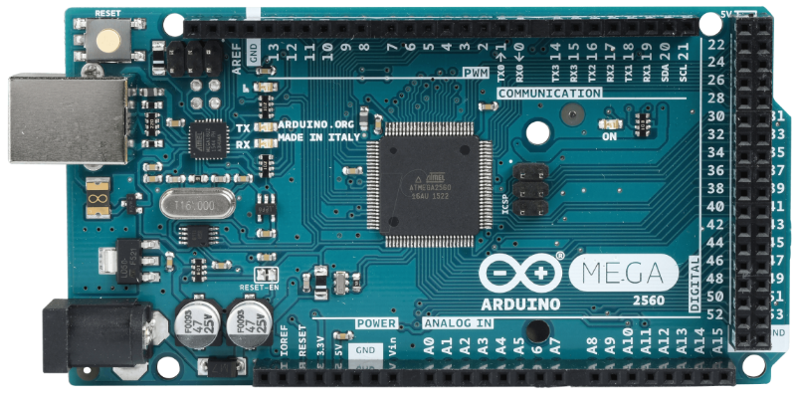

Figure 1: ARDUINO MEGA

The Arduino Mega 2560 is a microcontroller board based on the ATmega2560 (datasheet). It has 54 digital input/output pins (of which 14 can be used as PWM outputs), 16 analog inputs, 4 UARTs (hardware serial ports), a 16 MHz crystal oscillator, a USB connection, a power jack, an ICSP header, and a reset button. It contains everything needed to support the microcontroller simply connect it to a computer with a USB cable or power it with AC-to-DC adapter or battery to get started. The Mega is compatible with most shields designed for the Arduino.

Arduino Mega 2560 is an amazing microcontroller board for the projects that need large amount of input output pins or if high processing power is required. It is designed for more complex projects because as for simple projects large amount of input output pins are useless and a board with less memory fails to achieve our requirements. It can be used as a stand-alone project or in combination with other boards. Mostly it is used for creating a stand-alone project.

**2.1.2 PIN DESCRIPTION**

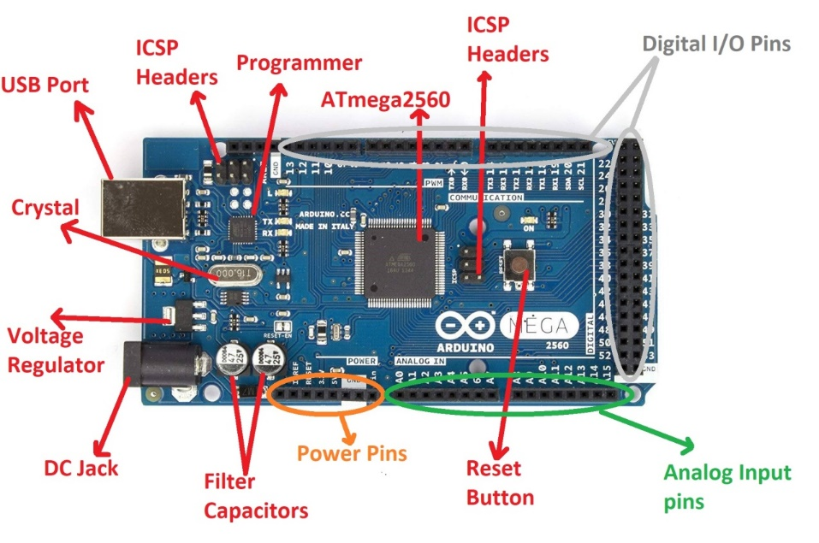

Figure 2: COMPONENT DESCRIPTION OF ARDUINO

* **ATmega2560 Microcontroller**

The Atmega2560 is a CMOS (Complementary Metal Oxide Semiconductor) low powered 8-bit microcontroller. The Mega 2560 is based on AVR RISC Architecture. Here, AVR stands for Audio Video Recorder and RISC stands for Reduced Instruction Set Computing.

* **USB Port**

It allows the board to connect to the computer. It is essential for the programming of the Arduino Mega board.

We usually plug the USB cable in the USB port to load the sketch to the board.

* **UART**

It stands for Universal Asynchronous Receiver and Transmitter. It permits the Arduino to communicate with serial devices.

* **Power Jack**

The power jack is used to supply the power to the board. The adapter is plugged-in to the power jack of the Arduino Mega board.

* **ICSP Header**

The program or firmware with the advanced functionalities is received by microcontroller with the help of the ICSP (In-Circuit Serial Programming) header.

* **IOREF**

It stands for Input Output voltage Reference. It allows the shields to check the operating voltage (3.3V or 5V) of the board. The shields are connected to the Arduino Board. The Microcontroller operates with the reference voltage provided by the IOREF.

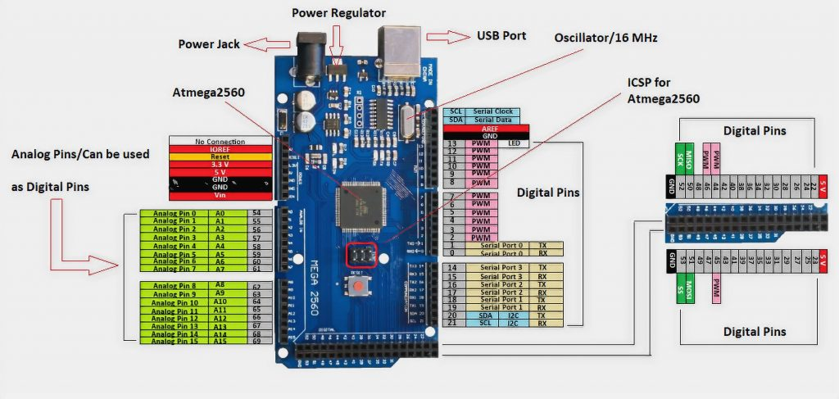

Figure 3: PIN DESCRIPTION OF ARDUINO

* **I2C**

It is the two-wire serial communication protocol. It stands for Inter-Integrated Circuits. The I2C is a serial communication protocol that uses SCL (Serial Clock) and SDA (Serial Data) to receive and send data between two devices. The SCL is a clock line, while SDA is a data line.

* **Analog pins**

There are total of 16 Analog pins from A0 - A15. The function of Analog pins is to read the analog sensor used in the connection. It can also act as GPIO (General Purpose Input Output) pins.

* **Digital Pins**

There are 54 digital Input/Output pins from pin numbered from 0 to 53. The 15 pins from the digital I/O are PWM (Pulse Width Modulation) pins numbered from D2 - D13 and D44 - D46. The digital pins have the value either HIGH or LOW.

* **SPI-SCK**

It stands for Serial Peripheral Interface. It is popularly used by the microcontrollers to communicate with one or more peripheral devices quickly. The SCK stands for serial clock. In slave, it works as the input of the clock generator. In master, it works as the output clock.

* **5V**

The 5V pin works as the output regulated voltage of 5V.

* **3.3V**

The 3V3 pin works as the output regulated voltage of 3.3V.

* **RX and TX**

The successful flow of data is represented by the lighting of the TX and RX LED.

* **Vin**

It is defined as the input voltage, which is applied to the Arduino Board when it is using an external power source.

**2.1.3 SPECIFICATIONS**

|  |  |
| --- | --- |
| Microcontroller | ATmega2560 |
| Operating Voltage | 5 V |
| Power supply | 7 V – 12 V |
| Current consumption | 50 mA – 200 mA |
| Current consumption Deep Sleep | 500 µA |
| Digital I/O Pins | 54 |
| Digital I/O Pins with PWM | 15 |
| Analog Input Pins | 16 |
| DC Current per I/O Pin | 40 mA |
| DC Current for 3.3V Pin | 50 mA |
| Flash Memory | 256 KB |
| SRAM | 8 KB |
| EEPROM | 4096 bytes |
| Clock Speed | 16 MHz |
| Length | 102 mm |
| Width | 53 mm |
| Power jack | yes |
| USB connection | yes |

Table 1: SPECIFICATIONS OF ARDUINO

* + 1. **ADVANTAGES:**
* It comes with more memory space, bigger size and more I/O pins.
* Speedy communication can be achieved since there is a reset button and 4 hardware serial port (USART).
* There are three ways to power the board either through USB cable, or by using Vin pin of the board, or through Power jack.
* This board comes with resettable poly fuse that prevents the USB port of your computer from overheating in the presence of high current flowing through the board.
* This board comes with two voltage regulator 5V and 3.3V which provides the flexibility to regulate the voltage as per requirements.

**2.1.5 DISADVANTAGES:**

* It is available only for 8-bits not for 32 bits.
* Clock speed is limited to 20 MHz

**2.1.4 APPLICATIONS**

**Robotics:**

Featuring the high processing capacity, the Arduino Mega 2560 can handle the extensive robotic applications. It is compatible with the motor controller shield that enables it to control multiple motors at an instance, thus making it perfect of robotic applications. The large number of I/O pins can accommodate many  
robotic sensors as well.

**3D Printing:**

Algorithms play a significant role in implementation of 3D printers. Arduino Mega 2560 has the power to process these complex algorithms required for 3D printing. Additionally, the slight changes to the code is easily possible with the Arduino IDE and thus 3D printing programs can be customized according to  
user requirements.

**Wi-Fi:**

Integrating wireless functionality enhances the utility of the applications. Arduino Mega 2560 is compatible with Wi-Fi shields hence allowing the wireless features for the applications in 3D printing and Robotics

**2.2 NodeMCU – ESP8266**

**2.2.1 INTRODUCTION**

NodeMCU is an open-source Lua based firmware and **development board** specially targeted for IoT based Applications. It includes firmware that runs on the ESP8266 Wi-Fi SoC from Espressif Systems, and hardware which is based on the ESP-12 module.

The NodeMCU ESP8266 development board comes with the ESP-12E module containing ESP8266 chip having Tensilica Xtensa 32-bit LX106 RISC microprocessor. This microprocessor supports RTOS and operates at 80MHz to 160 MHz adjustable clock frequency. NodeMCU has 128 KB RAM and 4MB of Flash memory to store data and programs. Its high processing power with in-built Wi-Fi / Bluetooth and Deep Sleep Operating features make it ideal for IoT projects.

NodeMCU can be powered using Micro USB jack and VIN pin (External Supply Pin). It supports UART, SPI, and I2C interface.

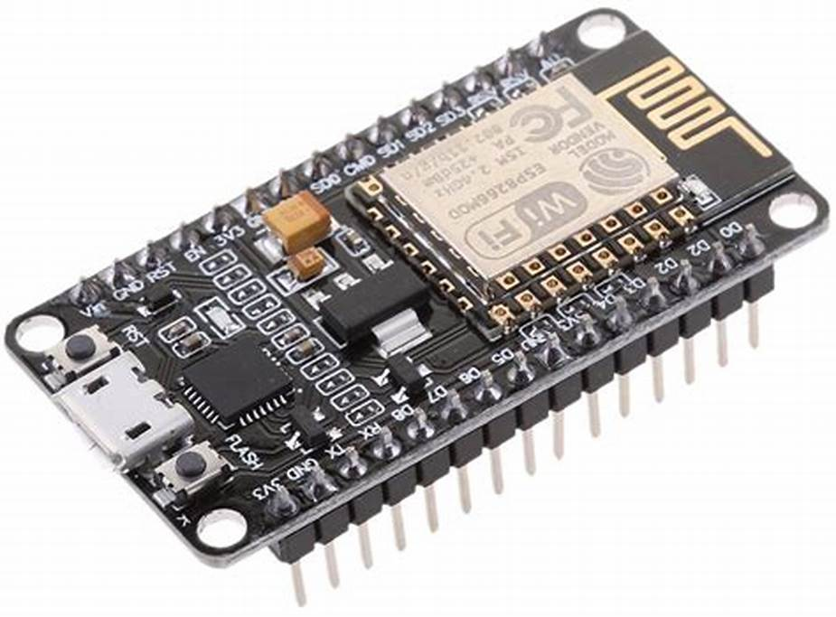

Figure 4: NodeMCU (ESP8266)

The NodeMCU Development Board can be easily programmed with Arduino IDE since it is easy to use. Programming NodeMCU with the Arduino IDE will hardly take 5-10 minutes. All you need is the Arduino IDE, a USB cable and the NodeMCU board itself.

Once Arduino IDE is installed on the computer, connect the board with the computer using the USB cable. Now open the Arduino IDE and choose the correct board by selecting Tools>Boards>NodeMCU1.0 (ESP-12E Module), and choose the correct Port by selecting Tools>Port. To get it started with the NodeMCU board and blink the built-in LED, load the example code by selecting Files>Examples>Basics>Blink. Once the example code is loaded into your IDE, click on the ‘upload’ button given on the top bar. Once the upload is finished, you should see the built-in LED of the board blinking.

**2.2.2 PIN DESCRIPTION**

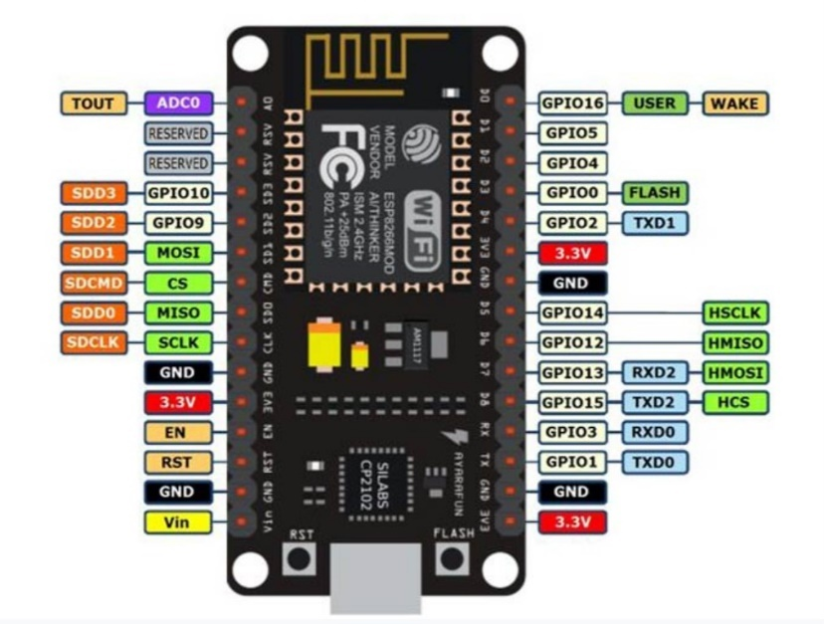

Figure 5: PIN DESCRIPTION OF NodeMCU

|  |  |  |
| --- | --- | --- |
| **Pin Category** | **Name** | **Description** |
| Power | Micro-USB, 3.3V, GND, Vin | Micro-USB: NodeMCU can be powered through the USB port    3.3V: Regulated 3.3V can be supplied to this pin to power the board    GND: Ground pins    Vin: External Power Supply |
| Control Pins | EN, RST | The pin and the button resets the microcontroller |
| Analog Pin | A0 | Used to measure analog voltage in the range of 0-3.3V |
| GPIO Pins | GPIO1 to GPIO16 | NodeMCU has 16 general purpose input-output pins on its board |
| SPI Pins | SD1, CMD, SD0, CLK | NodeMCU has four pins available for SPI communication. |
| UART Pins | TXD0, RXD0, TXD2, RXD2 | NodeMCU has two UART interfaces, UART0 (RXD0 & TXD0) and UART1 (RXD1 & TXD1). UART1 is used to upload the firmware/program. |
| I2C Pins |  | NodeMCU has I2C functionality support but due to the internal functionality of these pins, you have to find which pin is I2C. |

Table 2: PIN DESCRIPTION OF NodeMCU

**2.2.3 Components on NodeMCU**

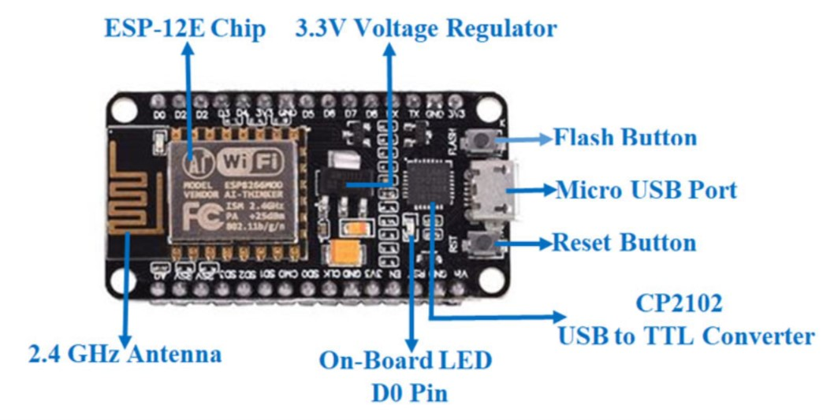

Figure 6: COMPONENTS ON NodeMCU

* ESP-12E Chip
* 3.3v Voltage Regulator
* 2.4GHz Antenna
* CP2102 USB to TTL Converter
* Micro USB Port
* On-Board LED D0 Pin
* Flash Button
* Reset Button

**2.2.4 Specifications & Features**

* Microcontroller: Tensilica 32-bit RISC CPU Xtensa LX106
* Operating Voltage: 3.3V
* Input Voltage: 7-12V
* Digital I/O Pins (DIO): 16
* Analog Input Pins (ADC): 1
* UARTs: 1
* SPIs: 1
* I2Cs: 1
* Flash Memory: 4 MB
* SRAM: 64 KB
* Clock Speed: 80 MHz
* USB-TTL based on CP2102 is included onboard, Enabling Plug n Play
* PCB Antenna
* Small Sized module to fit smartly inside your IoT projects

**2.2.5 Applications**

* Prototyping of IoT devices
* Low power battery operated applications
* Network projects
* Projects requiring multiple I/O interfaces with Wi-Fi and Bluetooth functionalities

**2.3 GSM MODULE – SIM800A**

**2.3.1 INTRODUCTION**

The SIM800A Quad-Band GSM/GPRS Module with RS232 Interface is a complete Quad-band GSM/GPRS solution in an LGA type which can be embedded in the customer applications. SIM800A support Quad-band 850/900/1800/1900 MHz, it can transmit Voice, SMS and data information with low power consumption. With a tiny size, it can fit into slim and compact demands of custom design. Featuring and Embedded AT, it allows total cost savings and fast time-to-market for customer applications.

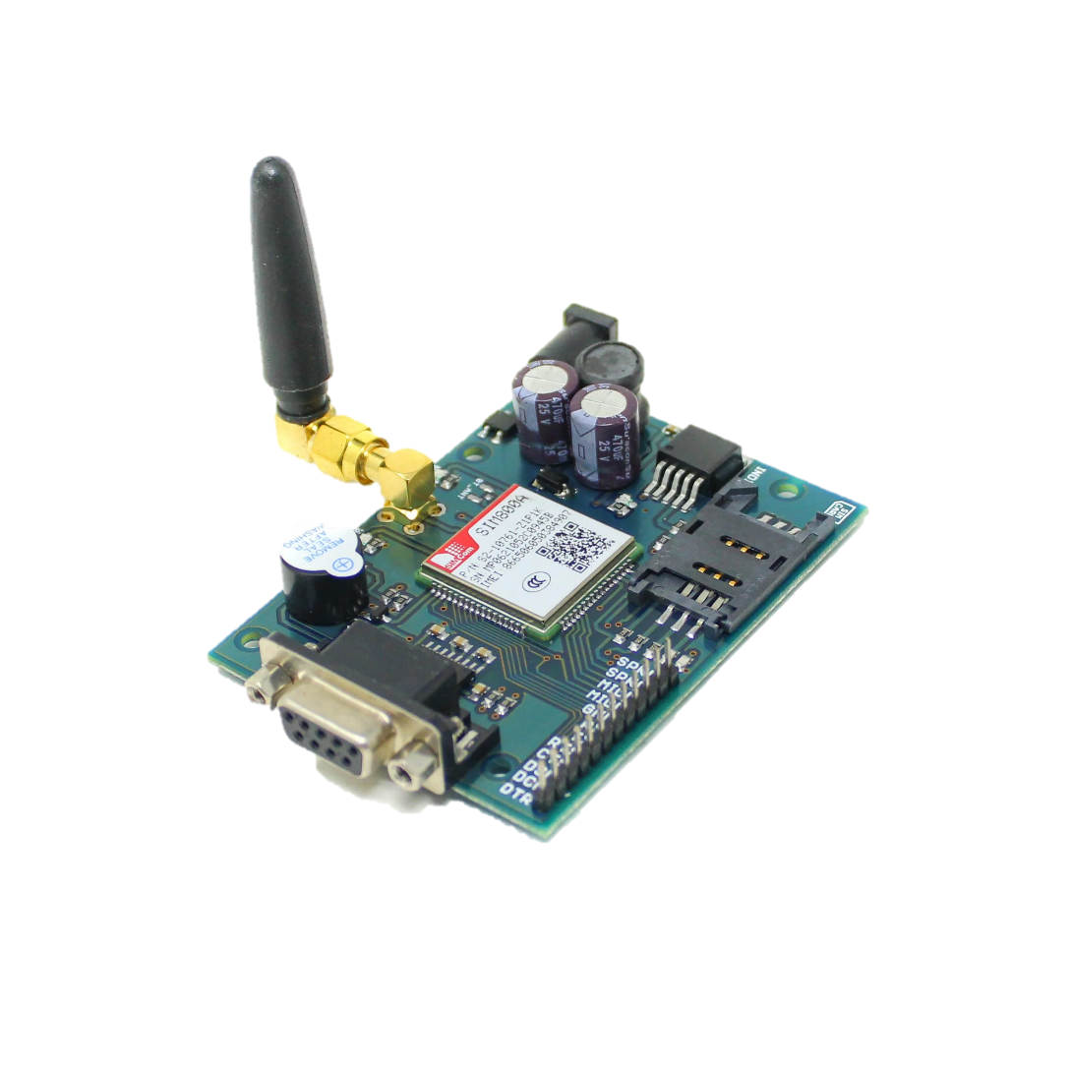

Figure 7: SIM800A

The SIM800A modem has a SIM800A GSM chip and RS232 interface while enables easy connection with the computer or laptop using the USB to the Serial connector or to the micro-controller using the RS232 to TTL converter. Once you connect the SIM800A modem using the USB to RS232 connector, you need to find the correct COM port from the Device Manager of the USB to Serial Adapter.

### **2.3.2 POWER SUPPLY FOR SIM800A**

The SIM800 needs to be powered by 3.7V which is a common standard among most cellular modules. One might think of using the Arduino’s 5V and 3.3V supply from the Arduino but this is not advisable.

The SIM800 is specified to use a power supply in the range of 3.4V to 4.3V. So, using 5V could damage the SIM800 module and 3.3V is not enough to reliably power it. Therefore, an external 3.7V Li-ion Polymer battery is used as the power source for the module.

**2.3.3 PIN DESCRIPTION**

The Module SIM800A looks like a single chip but it has a bunch of features that can help to build almost many commercial applications. Although, there are a total of 68 pins on SIM800A and using these pins helps to build the applications. But we will need few pins if you we use a module for interfacing with Arduino.

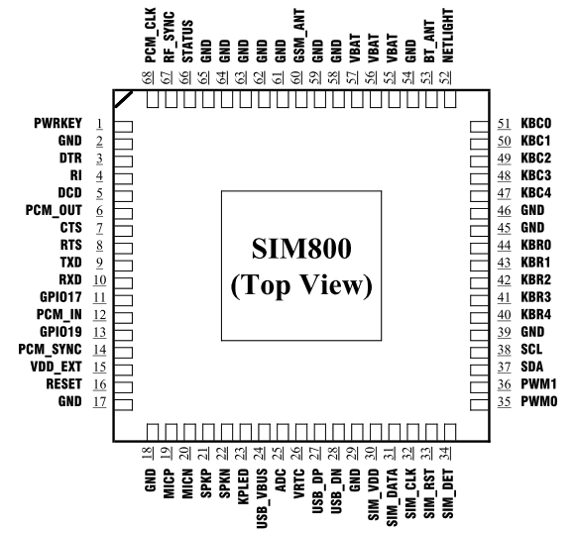

Figure 8: PIN CONFIGURATION OF GSM MODULE

**Status Pins:**

The module has two status pins which help to indicate two different kinds of status. The first one is the module and the second of communication status.Net status means either the module is connecting to the network or other network functions, etc. Both these pins can’t operate LED directly. They always act with a combination of a transistor.

STATUS - Pin 52

NIGHTLIGHT - Pin 66

**SIM800A Display Interface Pins:**

The device offers a 4 pins display interface with itself. The display isn’t necessary, it is only in case of requirement. The use of interface helps to get the visualization with the module and make it an application. All display pins are:

DISP_DATA -Pin 12 -For Display Data

DISP_CLK -Pin 11 -For Clock input

DISP_D/C -Pin 13 -To select Between data and command

It has 4 important pins for data and power transfer between other devices:

i.e., **TXD -** The Txd pin used to transmit the serial data

**RXD -** The Rxd pin used to receive the serial data

**VCC -** It is power pin. You can connect it to 3.3v or 5v output from your Arduino,

**GND -** It is ground pin. You can connect it to ground pin of Arduino

**2.3.4 WORKING:**

The SIM800A Quad-Band GSM/GPRS Module with RS232 Interface is a complete Quad-band GSM/GPRS solution in an LGA type which can be embedded in the customer applications. SIM800A support Quad-band 850/900/1800/1900 MHz, it can transmit Voice, SMS and data information with low power consumption. The SIM800A modem has a SIM800A GSM chip and RS232 interface while enables easy connection with the computer or laptop using the USB to the Serial connector or to the micro-controller using the RS232 to TTL converter. Once you connect the SIM800A modem using the USB to RS232 connector, you need to find the correct COM port from the Device Manager of the USB to Serial Adapter. Then you can open Putty or any other terminal software and open a connection to that COM port at 9600 baud which is the default baud rate of this modem.

Once a serial connection is open through the computer or your micro-controller you can start sending the AT commands. When you send AT commands for example “AT\r” you should receive back a reply from the SIM800A modem saying “OK” or other response depending on the command sent. Features Quad-band 850/900/1800/1900MHz. GPRS class 2/10. Control via AT commands (3GPP TS 27.007, 27.005 and SIMCOM enhanced AT command set). High-Quality Product (Not hobby grade). 5V interface for direct communication with MCU kit. Configurable baud rate. Built-in SIM Card holder. Built-in Network Status LED. Inbuilt Powerful TCP/IP protocol stack for internet data transfer over GPRS. Low power. Package Includes 1 x SIM800 A Quad-Band GSM/GPRS Modem with RS232 Interface.

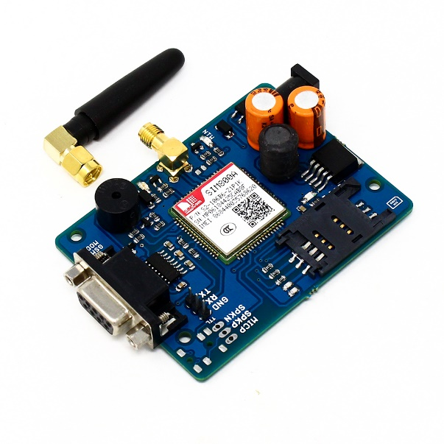

Figure 9: WORKING OF SIM800A

Communication between GSM module and microcontroller is done using AT commands by using standard serial connection [2]. The GSM module is designed to enable wireless communication for radiation monitoring instrument intended for continuous data monitoring and emergency alert. There are three configuration parameters that are essential to complete the task; the Host number, time interval for data transmission, and threshold level for alert SMS. These parameters are stored in EEPROM of microcontroller. User will be able to change and update the configuration parameters via SMS. Firmware of GSM microcontroller is implemented as a finite state machine as shown as the state. The firmware is responsible to handle task related to GSM/SMS communication with the Host server.

**2.3.5 SPECIFICATIONS**

* Bands: GSM 850MHz, EGSM 900MHz, PCS 1900MHz
* SIM800A Quad Band GSM Module
* Control via AT commands.
* Voltage Supply Required- 9VDC to 12VDC with at least 2A Peak Current Capability
* Built-in SIM Card holder.
* Built-in Network Status LED.
* Inbuilt Powerful TCP/IP protocol stack for internet data transfer over GPRS.
* Low power.
* Operating temperature: -40C to +85C
* External Finger type antenna

**2.3.6 ADVANTAGES:**

* GSM provides very cost affective products and solutions.
* The GSM based networks are deployed across the world and hence same mobile phone works across the globe. This leverages cost benefits as well as provides seamless wireless connectivity. This will help users avail data and voice services without any disruption. Hence international roaming is not a concern.
* Advanced versions of GSM with higher number of antennas will provide high speed download and upload of data.
* SAIC and DAIC techniques provide very high transmission quality. SAIC stands for Single Antenna Interference Cancellation technique while DAIC stands for Dual antenna interference cancellation.
* It is easy to maintain GSM networks due to availability of large number of network engineers at affordable cost. This will help in revenue increase by the telecom operators.
* The phone works based on SIM card and hence it is easy to change the different varieties of phones by users.
* The GSM signal does not have any deterioration inside the office and home premises.
* It is easy to integrate GSM with other wireless technology devices such as CDMA, LTE etc.

**2.3.7 DISADVANTAGES:**

* Many of the GSM technologies are patented by Qualcomm and hence licenses need to be obtained from them.
* In order to increase the coverage repeaters are required to be installed.
* GSM provides limited data rate capability, for higher data rate GSM advanced version devices are used.
* GSM uses FTDMA access scheme. Here multiple users share same bandwidth and hence will lead to interference when a greater number of users are using the GSM service. In order to avoid this situation, robust frequency correction algorithms are used in mobile phones and base stations.
* GSM uses pulse-based burst transmission technology and hence it interferes with certain electronics. Due to this fact airplanes, petrol bunks and hospitals prevent use of GSM based mobile or other gadgets

**2.3.8 APPLICATIONS**

* The module is the best application to design a graphic for Voice call and SMS application.
* Some IoT applications, mostly in an emergency have the module.
* The location trancing system also uses SIM800A.
* SIM800A can use for mobile communication

**2.4 PULSEOXYGEN SENSOR - MAX30100**

**2.4.1 INTRODUCTION**

#### Pulse Oximeters are low-cost non-Invasive medical sensors used to continuously measure the Oxygen saturation (SPO2) of haemoglobin in blood. It displays the percentage of blood that is loaded with oxygen.

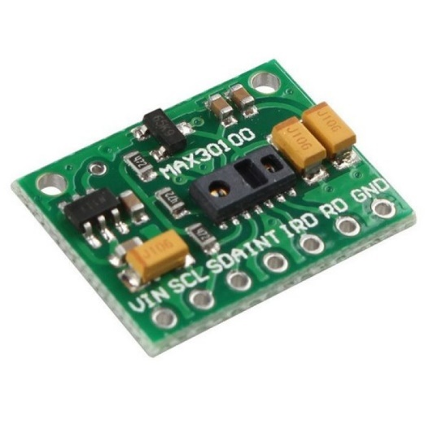

Figure 10: MAX30100

#### The principle of pulse oximetry is based on the differential absorption characteristics of oxygenated and the de-oxygenated haemoglobin. Oxygenated haemoglobin absorbs more infrared light and allows more red light to pass through. Whereas Deoxygenated haemoglobin absorbs more red light and allowing more infrared light to pass through.

#### Each pulse oximeter sensor probe contains two light emitting diode one emitting red light and the other emitting near infrared light, it also has a photo-detector. The photo-detector measures the intensity of transmitted light at each wavelength. And using the differences in the reading the blood oxygen content is calculated. The probe is placed on a suitable part of the body, usually a fingertip or ear lobe.

**2.4.2 HARDWARE DESCRIPTION**

The module features the MAX30100 – a modern, integrated pulse oximeter and heart rate sensor IC, from Analog Devices. It combines two LEDs, a photodetector, optimized optics, and low-noise analog signal processing to detect pulse oximetry (SpO2) and heart rate (HR) signals.

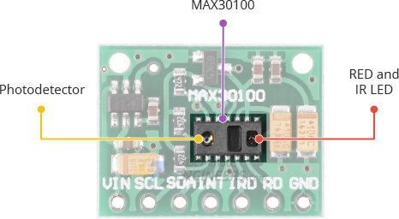

Figure 11: SENSOR ON MAX30100

On the right, the MAX30100 has two LEDs – a RED and an IR LED. And on the left is a very sensitive photodetector. The idea is that you shine a single LED at a time, detecting the amount of light shining back at the detector, and, based on the signature, you can measure blood oxygen level and heart rate.

### **Power Requirement**

### The MAX30100 chip requires two different supply voltages: 1.8V for the IC and 3.3V for the RED and IR LEDs. So, the module comes with 3.3V and 1.8V regulators. This allows you to connect the module to any microcontroller with 5V, 3.3V, even 1.8V level I/O.

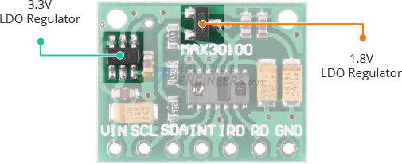

Figure 12: POWER REQUIREMENT OF MAX30100

One of the most important features of the MAX30100 is its low power consumption: the MAX30100 consumes less than 600μA during measurement. Also, it is possible to put the MAX30100 in standby mode, where it consumes only 0.7μA. This low power consumption allows implementation in battery powered devices such as handsets, wearables or smart watches.

### **On-Chip Temperature Sensor**

The MAX30100 has an on-chip temperature sensor that can be used to compensate for the changes in the environment and to calibrate the measurements. This is a reasonably precise temperature sensor that measures the ‘die temperature’ in the range of -40˚C to +85˚C with an accuracy of ±1˚C.

### **I2C Interface**

The module uses a simple two-wire I2C interface for communication with the microcontroller. It has a fixed I2C address: 0xAEHEX (for write operation) and 0xAFHEX (for read operation).

### **FIFO Buffer**

The MAX30100 embeds a FIFO buffer for storing data samples. The FIFO has a 16-sample memory bank, which means it can hold up to 16 SpO2 and heart rate samples. The FIFO buffer can offload the microcontroller from reading each new data sample from the sensor, thereby saving system power.

### **Interrupts**

### The MAX30100 can be programmed to generate an interrupt, allowing the host microcontroller to perform other tasks while the data is collected by the sensor. The interrupt can be enabled for 5 different sources:

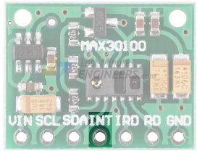

Figure 13: INTERRUPT IN MAX30100

* **Power Ready**: triggers on power-up or after a brownout condition.
* **SpO2 Data Ready**: triggers after every SpO2 data sample is collected.
* **Heart Rate Data Ready**: triggers after every heart rate data sample is collected.
* **Temperature Ready**: triggers when an internal die temperature conversion is finished.
* **FIFO Almost Full**: triggers when the FIFO becomes full and future data is about to lost

|  |  |
| --- | --- |
| **Pin Type** | **Pin Function** |
| VIN | Voltage Input |
| SCL | I2C - Serial Clock |
| SDA | I2C - Serial Data |
| INT | Active low interrupt |
| IRD | IR LED Cathode and LED Driver Connection Point(Leave floating in the circuit) |
| RD | Red LED Cathode and LED Driver Connection Point(Leave floating in the circuit) |
| GND | Ground pin |

Table 3: PIN DESCRIPTION OF MAX30100

**2.4.3 WORKING OF MAX30100**

The MAX30102, or any optical pulse oximeter and heart-rate sensor for that matter, consists of a pair of high-intensity LEDs (RED and IR, both of different wavelengths) and a photodetector. The wavelengths of these LEDs are 660nm and 880nm, respectively.

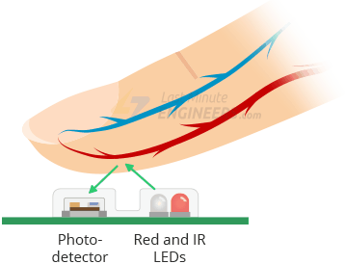

Figure 14: WORKING OF MAX30100

The MAX30102 works by shining both lights onto the finger or earlobe (or essentially anywhere where the skin isn’t too thick, so both lights can easily penetrate the tissue) and measuring the amount of reflected light using a photodetector. This method of pulse detection through light is called Photoplethysmogram.

The working of MAX30102 can be divided into two parts: Heart Rate Measurement and Pulse Oximetry (measuring the oxygen level of the blood).

### **Heart Rate Measurement**

The oxygenated haemoglobin (HbO2) in the arterial blood has the characteristic of absorbing IR light. The redder the blood (the higher the haemoglobin), the more IR light is absorbed. As the blood is pumped through the finger with each heartbeat, the amount of reflected light changes, creating a changing waveform at the output of the photodetector. As you continue to shine light and take photodetector readings, you quickly start to get a heart-beat (HR) pulse reading.

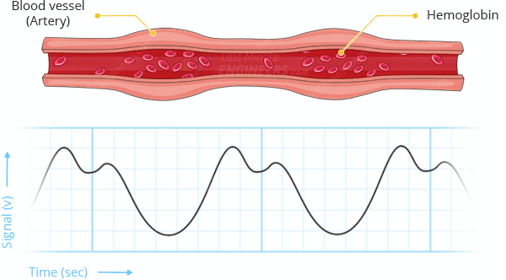

Figure 15: HEART RATE MEASUREMENT OF MAX30100

### **Pulse Oximetry**

Pulse oximetry is based on the principle that the amount of RED and IR light absorbed varies depending on the amount of oxygen in your blood. The following graph is the absorption-spectrum of oxygenated haemoglobin (HbO2) and deoxygenated haemoglobin (Hb).

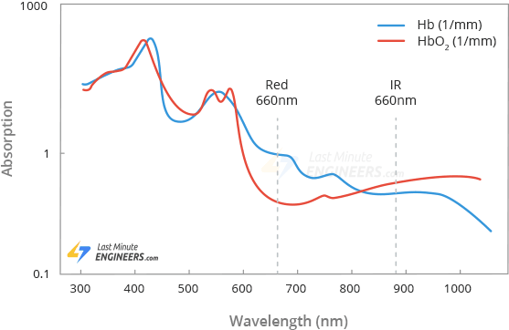

Figure 16: SPO2 MEASUREMENT IN MAX30100

As you can see from the graph, deoxygenated blood absorbs more RED light (660nm), while oxygenated blood absorbs more IR light (880nm). By measuring the ratio of IR and RED light received by the photodetector, the oxygen level (SpO2) in the blood is calculated.

**2.4.4 Functional Block diagram of MAX30100 Module**

Below is the functional block for the MAX30100 module. The module consists of two LEDs (IR and RED) both of specific wavelengths, along with a photodetector to detect the received light.

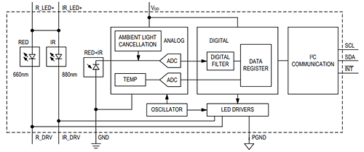

Figure 17: FUNCTIONAL BLOCK DIAGRAM OF MAX30100

The output from the photodiode is sent to the analog-to-digital converter from which the digital data is sent from a filter to the digital data register. The data can be collected from the register and can be sent to the microcontroller following the I2C communication protocol.

**2.4.5 Connecting MAX 30100 Module to a Microcontroller**

Here it shows the connections from MAX30100 to the Arduino microcontroller below. The pulse oximeter uses an I2C communication protocol in order to communicate with the microcontroller. The connections are pretty simple and you can easily make your own Arduino oximeter.

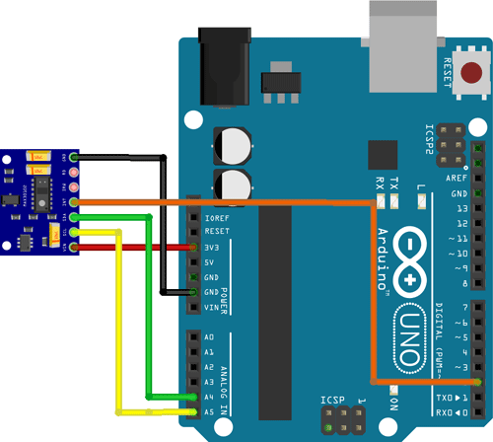

Figure 18: CONNECTION MAX30100 WITH MICROCONTROLLER

Vin is connected to the 3.3V port of Arduino since the operating voltage of the module is 1.8V-3.3V. The ground terminal of the oximeter is connected to the ground of the Arduino. As part of the communication protocol, two pins which are the SCL and SDA are connected to the Arduino’s A5 and A4 pins, respectively. The INT pin on the module is also connected to the microcontroller’s Digital Pin 2 to check if the heartbeat is captured properly

**2.4.6 SPECIFICATIONS**

|  |  |
| --- | --- |
| Power supply | 3.3V to 5.5V |
| Current draw | ~600μA (during measurements) |
| ~0.7μA (during standby mode) |
| Red LED Wavelength | 660nm |
| IR LED Wavelength | 880nm |
| Temperature Range | -40˚C to +85˚C |
| Temperature Accuracy | ±1˚C |

Table 4: SPECIFICATIONS OF MAX30100

#### **2.4.7 ADVANTAGES**

#### Ultra-Low-Power Operation Increases Battery Life for Wearable Devices

#### Programmable Sample Rate and LED Current for Power Savings

#### Ultra-Low Shutdown Current (0.7µA)

#### Advanced Functionality Improves Measurement Performance

#### High SNR Provides Robust Motion Artifact Resilience

#### Integrated Ambient Light Cancellation

#### High Sample Rate Capability

#### Fast Data Output Capability

**2.4.8 APPLICATIONS**

* Medical Oxygen measurement devices
* Wearable Devices
* Fitness Assistant systems

**2.5 TEMPERATURE SENSOR - GY-906**

* + 1. **INTRODUCTION**

The GY-906 MLX90614 is an IR based contactless temperature sensor that can measure the temperature of a particular object between -70°C – 382.2°C and an ambient temperature of -40°C – 125°C without even making physical contact with an object under observation. It is embedded with an I2C port to communicate temperature reading to microcontrollers over an I2C bus. On top of that, it is provided with ESD protection to avoid malfunctioning of the sensor.

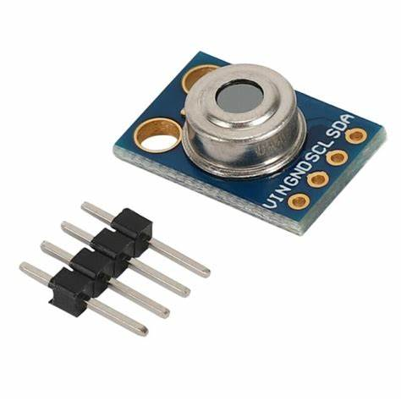

Figure 19: GY906

The tiny device is highly accurate and precise due to its powerful ADC. A 17-bit ADC is embedded in the module to output the values with 0.14 ˚C of resolution. Melexis has introduced different versions of this sensor based on input voltage requirements i.e., 3 Volts or 5volts and resolving power for different project requirements. But MLX90614 is a sensitive temperature sensor that has a long list of applications, especially in home automation.

**2.5.2 HARDWARE OVERVIEW**

At the heart of the module is a high precision non-contact infrared temperature sensor from Melexis – **MLX90614**. Unlike most temperature sensors, this sensor measures temperature without being physically touched. This can be very useful for monitoring the temperature of something moving like a spinning motor shaft or objects on a conveyor belt for example. Simply point the sensor at what you want to measure and it will detect the temperature by absorbing the emitted IR waves.

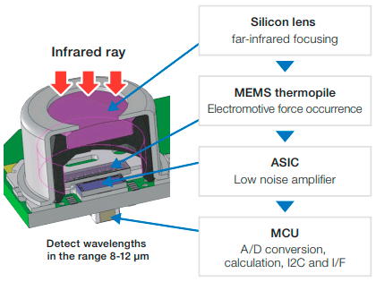

Figure 20: HARDWARE DESCRIPTION OF GY906

### **Capabilities**

The MLX90614 generates two temperature measurements: an object temperature and an ambient temperature. The object temperature is the non-contact measurement ‘observed’ from the sensor, while the ambient temperature measures the temperature on the die of the sensor. Ambient temperature can be used to calibrate the data, but what we really need comes from object temperature measurements.

Because it does not have to touch the object being measured, it can sense a wider range of temperatures than most digital sensors: object temperature measurements range from -70 to 382.2°C, while ambient temperature measurements range from -40 to 125°C. Both the ambient temperature and the object temperature have a resolution of 0.02°C with a standard accuracy of 0.5°C around room temperatures.

### **Built-In Optical Filter**

The MLX90614 has a built-in optical filter that cuts off visible and near-infrared light, reducing their effect on measurements. It also provides immunity against ambient light and sunlight.

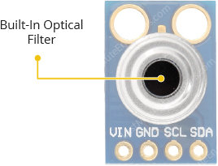

Figure 21: OPTICAL FILTER OF GY906

### **Power Requirement**

The module comes with a 662K 3.3V precision voltage regulator and voltage level translator, so you can use it with your favourite 3.3V or 5V microcontroller without any worries.

The MLX90614 consumes less than 2mA during measurement. This low power consumption allows implementation in battery powered devices such as handheld thermal scanners.

**2.5.3 WORKING**

Infrared thermometers like MLX90614 take advantage of the fact that any object, including humans, above absolute zero (0°K or -273°C) temperature, emits (not visible to the human eye) light in the infrared spectrum that is directly proportional to its temperature. Refer to the Stefan–Boltzmann law.

Internally, the MLX90614 is a pair of two devices: an infrared thermopile detector and an ASSP (Signal-Conditioning Application Processor). Here is the internal block diagram of the MLX90614 showing both the thermopile and the ASSP.

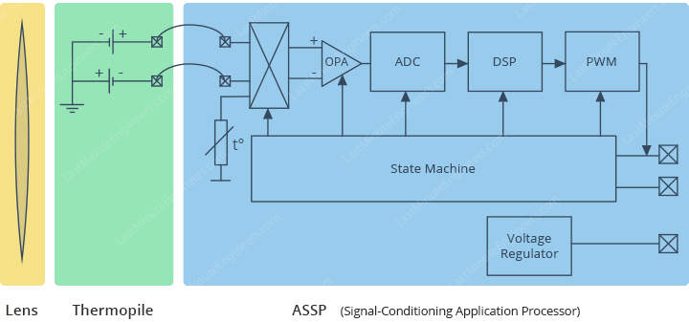

Figure 22: FUNCTIONAL BLOCK DIAGRAM OF GY906

The IR radiation emitted by an object or human is first focused by a converging (convex) lens onto a special infrared detector called a **Thermopile**. The thermopile senses how much infrared energy is being emitted by objects in its field-of-view (FOV), and generates an electrical signal proportional to that.

The voltage produced by the thermopile is picked up by the ASSP’s 17-bit ADC and then processed before passing to the microcontroller. The best part is that this whole process is achieved in a fraction of a second.

## Field of View (FOV)

An IR thermometer’s field-of-view (FOV) is one of the most important metrics to be aware of.

It is determined by the angle in which the sensor is sensitive to thermal radiation. This means that the sensor will detect all objects in the field-of-view and return the average temperature of all objects in it.

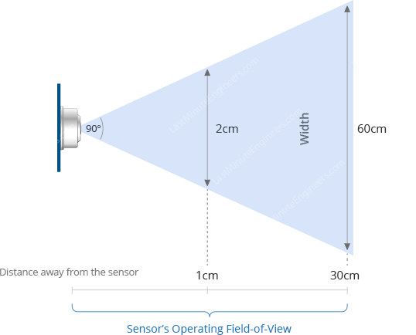

Figure 23: FOV OF GY906

It is important that the measured object completely fills the field-of-view. Otherwise, the sensor may detect objects that are not supposed to be measured, resulting in inaccurate measurements.

The field-of-view also determines the relationship between the distance from an object and the sensing area. If the sensor is near the object, its sensing area is very narrow, but gets increasingly wider as it moves farther away.

The field-of-view of the MLX90614 is cone-shaped and relatively wide: 90°. This means that for every 1cm you move away from an object, the sensing area increases by 2cm. If you are one-foot 30cm (approx. 1 foot) away from an object, the sensing area will be 60cm (approx. 2 feet).

**2.5.2 PIN DESCRIPTION**

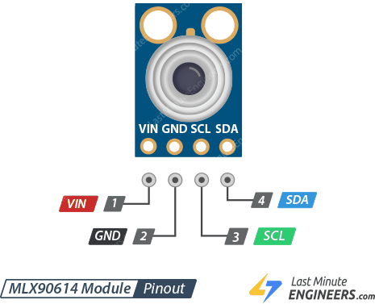

Figure 24: PIN DESCRIPTION OF GY906

|  |  |  |
| --- | --- | --- |
| **Pin** | **Type** | **Parameters** |
| Pin 1 | VSS | It is a ground pin. |
| Pin 2 | SCL | It is Serial Clock input for a protocol of two wire. At this pin, there is a Zener diode of 5.7V to connect it with other Bipolar transistors. |
| Pin 3 | PWM / SDA | It is digital input and output pin, the measured value of temperature can get by this pinout. |
| Pin 4 | VDD | It is an external power supply. |

Table 5: PIN DESCRIPTION OF GY906

### **2.5.3 INTERFACING MLX90614 SENSOR WITH ARDUINO**

The interfacing of MLX90614 Sensor with Arduino is quite very simple as the MLX90614 sensor provides temperature output on the I2C bus. Also, the Arduino board has an on-board I2C bus. We have seen may interfacing tutorials for I2C with Arduino.

Start by connecting the VCC pin to the power supply, 5V is fine. Use the same voltage that your microcontroller logic is based off of. For most Arduinos, that is 5V. For 3.3V logic devices, use 3.3V. Now connect GND to common ground.

Connect the SCL pin to the I2C clock pin and the SDA pin to the I2C data pin on your Arduino. Note that each Arduino Board has different I2C pins which should be connected accordingly. On the Arduino boards with the R3 layout, the SDA (data line) and SCL (clock line) are on the pin headers close to the AREF pin. They are also known as A5 (SCL) and A4 (SDA).

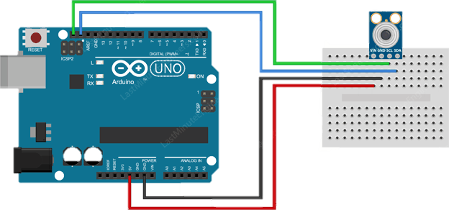

Figure 25: INTERFACING GY906 TO ARDUINO

**2.5.3 SPECIFICATIONS**

|  |  |
| --- | --- |
| Operating Voltage | 3.3V – 5.5V |
| Ambient Temperature Range | -40°C – 125°C |
| Object Temperature Range | -70°C – 380°C |
| Measurement Resolution | ±0.2°C |
| Temperature Accuracy | ±0.5°C |
| ESD Sensitivity | 2kV |
| Sink/Source Current | 25mA |
| ADC Resolution | 17 bits |

Table 6: SPECIFICATIONS OF GY906

**2.5.4 APPLICATIONS**

* High precision non-contact temperature measurements
* Thermal Comfort sensor for Mobile Air Conditioning control system
* Temperature sensing element for residential, commercial and industrial building air conditioning
* Windshield defogging
* Automotive blind angle detection
* Industrial temperature control of moving parts
* Temperature control in printers and copiers
* Home appliances with temperature control
* Healthcare
  1. **ECG SENSOR- AD8232**
     1. **INTRODUCTION**

**ABOUT ECG**

An ECG is a paper or digital recording of the electrical signals in the heart. It is also called an electrocardiogram or an EKG. The ECG is used to determine heart rate, heart rhythm, and other information regarding the heart’s condition. ECGs are used to help diagnose heart arrhythmias, heart attacks, pacemaker function, and heart failure.

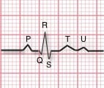

Figure 26: ECG GRAPH

ECG can be analysed by studying components of the waveform. These waveform components indicate cardiac electrical activity. The first upward of the ECG tracing is the P wave. It indicates atrial contraction.

The QRS complex begins with Q, a small downward deflection, followed by a larger upwards deflection, a peak (R); and then a downwards S wave. This QRS complex indicates ventricular depolarization and contraction.

Finally, the T wave, which is normally a smaller upwards waveform, representing ventricular re-polarization.

**ABOUT SENSOR**

This sensor is a cost-effective board used to measure the electrical activity of the heart. This electrical activity can be charted as an ECG or Electrocardiogram and output as an analog reading. ECGs can be extremely noisy, the AD8232 Single Lead Heart Rate Monitor acts as an op-amp to help obtain a clear signal from the PR and QT Intervals easily.

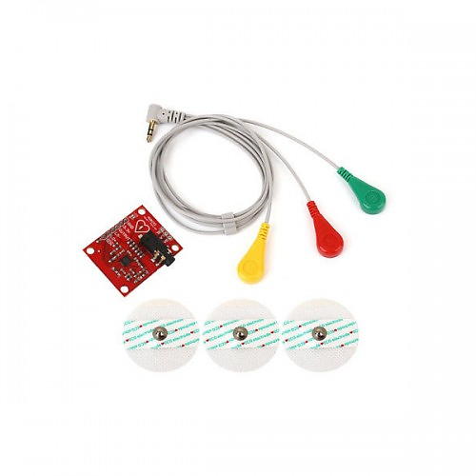

Figure 27: ECG SENSOR

The AD8232 is an integrated signal conditioning block for ECG and other biopotential measurement applications. It is designed to extract, amplify, and filter small biopotential signals in the presence of noisy conditions, such as those created by motion or remote electrode placement.

The AD8232 module breaks out nine connections from the IC that you can solder pins, wires, or other connectors to. SDN, LO+, LO-, OUTPUT, 3.3V, GND provide essential pins for operating this monitor with an Arduino or other development board. Also provided on this board are RA (Right Arm), LA (Left Arm), and RL (Right Leg) pins to attach and use your own custom sensors. Additionally, there is an LED indicator light that will pulsate to the rhythm of a heartbeat.

**2.6.2 WORKING**

The AD8232 module allows recording the electrical activity of the heart, by obtaining an electrocardiogram or ECG.

ECG sensor obtain signals from heart beats because electrical signals are transmitted through specific pathways within the heart, causing the **heartbeat.** This electrical activity can be collected through electrodes placed on the skin, specifically on the front of the chest, on the arms and legs.

The AD8232 sensor module is integrated with specially calibrated signal amplifiers and noise filters for ECG signals. The module suppresses the 60Hz noise generated by household electricity. As the output of the module is analog type, it is necessary to solder the header pins and connect the module to a microcontroller which has analog input pins like Arduino, ESP32, ESP8266 NodeMCU, or others. Within the program we must perform the analog to digital conversion, so we can observe the ECG on the Arduino IDE plotter.

It is recommended for patient safety to power the module using a battery and not from a source connected to the household power supply.

**2.6.3 PIN DESCRIPTION**

The heart rate monitoring sensor like AD8232 includes the pins like SDN pin, LO+ pin, LO- pin, OUTPUT pin, 3.3V pin, and GND pin. So that we can connect this IC to development boards like Arduino by soldering pins.

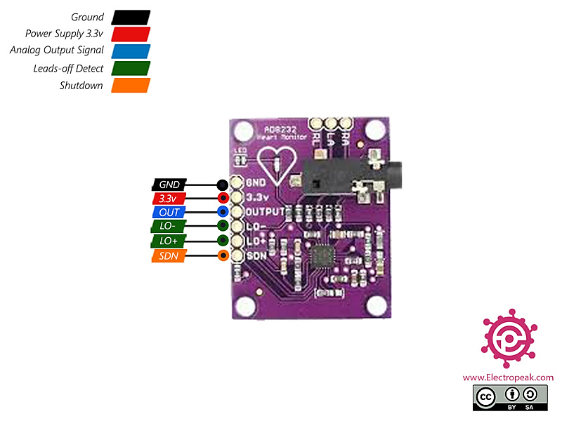

Figure 28: PIN DESCRPITION OF AD8232

Additionally, this board includes pins like the right arm (RA), left arm (LA) & right leg (RL) pins to connect custom sensors. An LED indicator in this board is used to indicate the heartbeat rhythm of humans.

The AD8232 sensor comprises a function like quick restore, used to decrease the length of long resolving tails of the HPFs. This sensor is accessible in a 4 mm × 4 mm size, and the package of this sensor is 20-lead LFCSP. It operates from −40°C -to- +85°C but the performance is specified from 0°C -to- 70°C.

**2.6.4 INTERFACE OF ECG WITH ARDUINO**

The AD8232 Heart Rate Monitor breaks out nine connections from the IC. We traditionally call these connections “pins” because they come from the pins on the IC, but they are actually holes that you can solder wires or header pins to.

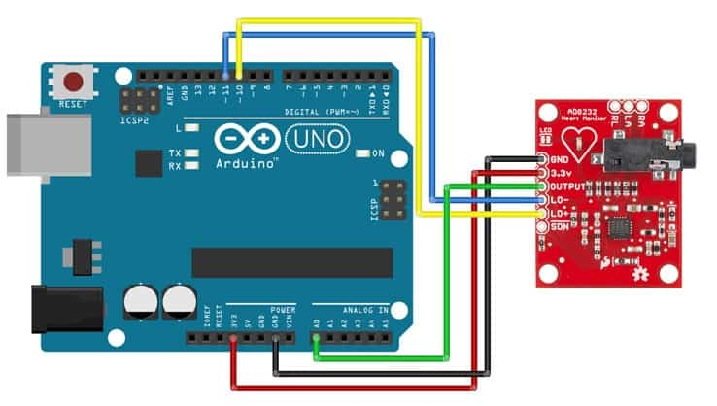

Figure 29: INTERFACING AD8232 WITH ARDUINO

We’ll connect five of the nine pins on the board to Arduino. The five pins you need are labelled GND, 3.3v, OUTPUT, LO-, and LO+.

|  |  |  |
| --- | --- | --- |
| **Pin Name** | **Function** | **Details** |
| LO+ | Lead OFF Positive | In DC Lead Off Detection mode, LO+ is LOW when electrode at +IN (of IC AD8232), i.e., LA (of module AD8232) is connected, and LO+ is HIGH when electrode at +IN (of IC AD8232) i.e. LA (of module AD8232) is disconnected. In AC Lead Off Detection mode, LO+ is LOW when electrodes at both +IN and –IN (of IC AD8232) i.e. LA and RA (of module AD8232) are connected, and LO+ is HIGH when the electrode at LA or RA is disconnected. |
| LO- | Lead OFF Negative | In DC Lead Off Detection mode LO- is LOW when electrode at –IN (of IC AD8232) i.e. RA (of module AD8232) is connected and LO- is HIGH when electrode at –IN (of IC AD8232) i.e., RA (of module AD8232) is disconnected. In AC Lead Off detection mode LO- is always LOW. |
| OUTPUT |  | This is an output pin at which a filtered analog signal is present, and it gives the electrical activity of the heart. This signal can be feed as an analog input to the Analogue to digital converter or microcontroller for analysis and visualization. |
| 3.3 V | Power | This is + ve Pin of 3.3V to power up the module. |
| GND | Ground | This is the Ground Pin of 3.3V to power up the module. |
| SDN | Shut Down | When SDN pin is set to low, the module enters low power shutdown mode. |

Table 7: PIN DESCRIPTION OF AD8232

### **2.6.5** **AD8232 ECG SENSOR PLACEMENT ON BODY**

### It is recommended to snap the sensor pads on the leads before application to the body. The closer to the heart the pads are, the better the measurement. The cables are color-coded to help identify proper placement.

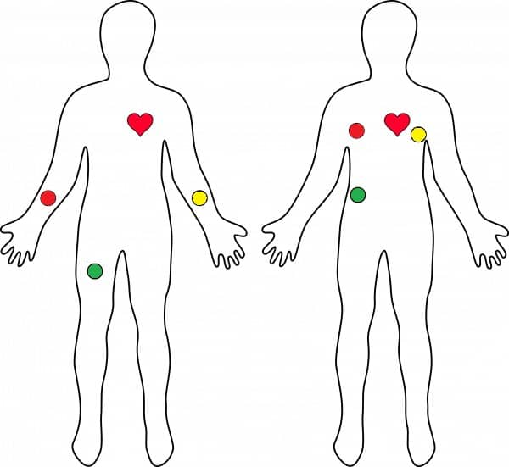

Figure 30: AD8232 PLACEMENT ON BODY

* Red: RA (Right Arm)
* Yellow: LA (Left Arm)
* Green: RL (Right Leg)

**2.6.7 SPECIFICATIONS**

* Operation of single supply ranges from 2V to 3.5V
* The front end is integrated fully with only lead ECG
* The virtual ground can be generated through integrated reference
* RFI filter is used internally
* The current supply is low like 170 µA
* The output is rail to rail
* Shutdown pin
* CMRR is 80 dB
* Incorporated RLD amplifier (right leg drive
* Electrode configurations are 2 or 3
* The operational amplifier is uncommitted
* It accepts half-cell potential up to ±300 mV
* Three-pole adaptable LPF with adaptable gain
* The signal gain is high using DC blocking capacity
* Filter settling can be improved by quick restore
* Two-pole adaptable HPF
* 4 mm × 4 mm and 20-lead LFCSP package

**2.6.8 APPLICATIONS**

* Monitoring of heart and fitness activity
* Handy ECG
* Monitoring of remote health
* Used in gaming devices
* Acquisition of biopotential signal
* Biometrics
* Physiology studies
* Prototyping of biomedical instruments
* Variability of heart rate
* Interaction of human-computer
* Psychophysiology

**2.7 DISPLAY - LCD 16X2**

**2.7.1 INTRODUCTION**

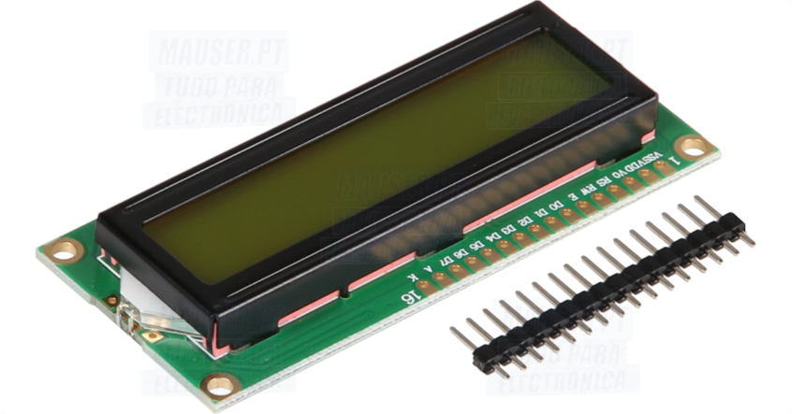

Figure 31: LCD 16X2

In LCD 16×2, the term LCD stands for Liquid Crystal Display that uses a plane panel display technology, used in screens of computer monitors & TVs, smartphones, tablets, mobile devices, etc. Both the displays like LCD & CRTs look the same but their operation is different. Instead of electrons diffraction at a glass display, a liquid crystal display has a backlight that provides light to each pixel that is arranged in a rectangular network.

Every pixel includes a blue, red, green sub-pixel that can be switched ON/OFF. Once all these pixels are deactivated, then it will appear black and when all the sub-pixels are activated then it will appear white. By changing the levels of each light, different colour combinations are achievable. This article discusses an overview of LCD 16X2 & its working with applications.

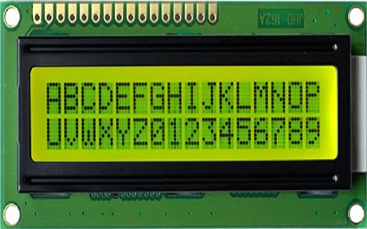

Figure 32: TEXT ON LCD

An electronic device that is used to display data and the message is known as LCD 16×2. As the name suggests, it includes 16 Columns & 2 Rows so it can display 32 characters (16×2=32) in total & every character will be made with 5×8 (40) Pixel Dots. So the total pixels within this LCD can be calculated as 32 x 40 otherwise 1280 pixels.

16X2 displays mostly depend on multi-segment LEDs. There are different types of displays available in the market with different combinations such as 8×2, 8×1, 16×1, and 10×2, however, the LCD 16×2 is broadly used in devices, DIY circuits, electronic projects due to less cost, programmable friendly & simple to access.

**2.7.2 CONSTRUCTION**

The liquid crystal having a thickness of nearly about **10 to 20 micrometres** is placed between two glass sheets. On the inner surface of the two glass sheets, conductors are inserted. These conductors form electrodes. The two electrodes show positive and negative polarity to be applied. The external potential is provided to the display unit with the help of these two electrodes. These are basically formed by materials like indium oxide **(IN2O3)** and stannic oxide **(SnO3)**.

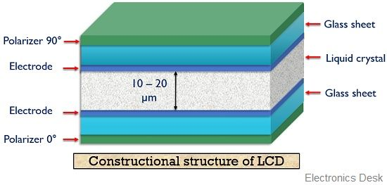

Figure 33: CONSTRUCTION OF LCD

Here, a fluorescent light source is used. The light emitted by this source is then fed to the polarizer here we have considered a vertical polarizer as the input polarizer. Also, a polarizer of opposite polarity as that of input is placed at another end of the display unit. So, here if we have assumed vertical polarizer as the input polarizer then at the other end it must be a horizontal polarizer. At the opposite end of the electrode, a glass cover is placed at which the desired image is displayed.

**2.7.3 WORKING**

As we already have the idea that **LCD is not an electroluminescent device**. This means it does not have light-producing property instead of that it allows light to appear bright or dark by making use of a liquid crystal. Now, let us proceed to understand the operation of LCD.

When light from a backlight source is emitted and allowed to fall on the vertical polarizer. Then the unpolarized light by the source gets vertically polarized. When initially no external potential is provided between the two electrodes, the molecules of the liquid crystal remain twisted. This causes the vertically polarized light to get horizontally polarized due to the orientation of the molecules.

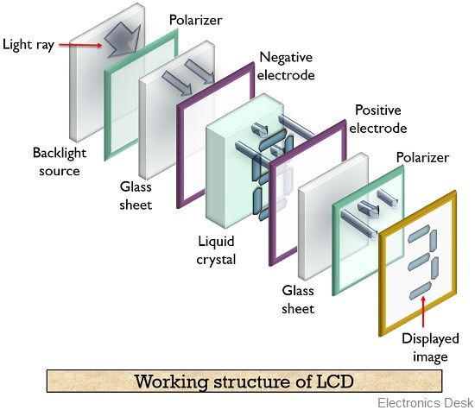

Figure 34: WORKING OF LCD

As we have discussed that the orientation of the two polarizers is 90° in accordance with each other. Thus, the polarizer at the other end is a horizontal polarizer. Hence, when the horizontally polarized light from the output of the nematic crystal is fed to the horizontal polarizer then it passes the light thereby causing illumination of the pixel. Hence, generates a visible image on the screen.

Suppose when a large voltage is applied between the two electrodes. Then this applied voltage causes the twisted mechanism of the molecules to get damaged causing them to operate in a straight manner. Due to this, the vertically polarized light while passing the nematic crystal does not change its polarization. This blocks the vertically polarized light to pass the horizontal polarizer thereby generating a dark pixel at the display. In this way, bright and dark images are generated.

### **Data Display**

The data display will also get through the digital pins. The data pins will send the data from the digital pins to the data register, whenever there will HIGH input signal at RS pin. All the data in alphabets or other words the ASCII code will able to show at the LCD. After transferring the data, the enable pin also needs to get the LOW to HIGH pulse. The LOW to high pulse needs only for few milliseconds. Therefore, to show the data on pixel grids, commands need to store within the module. If the command isn’t set according to each required function, then the LCD will display the data according to the previously sent commands. So always send the commands before showing any data.

**2.7.4 PIN DESCRIPTION**

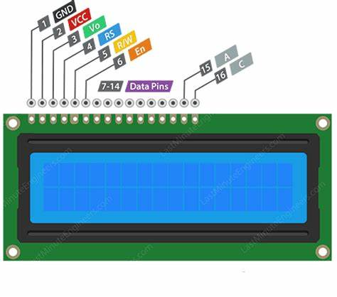

Figure 35: PIN DESCRIPTION OF LCD

|  |  |  |
| --- | --- | --- |
| **Pin No.** | **Function** | **Name** |
| 1 | Ground (0V) | Ground |
| 2 | Supply voltage; 5V (4.7V – 5.3V) | VCC |
| 3 | Contrast adjustment; the best way is to use a variable resistor such as a potentiometer. The output of the potentiometer is connected to this pin. Rotate the potentiometer knob forward and backwards to adjust the LCD contrast. | Vo / VEE |
| 4 | Selects command register when low, and data register when high | RS (Register Select) |
| 5 | Low to write to the register; High to read from the register | Read/write |
| 6 | Sends data to data pins when a high to low pulse is given; Extra voltage push is required to execute the instruction and EN (enable) signal is used for this purpose. Usually, we set en=0, when we want to execute the instruction, we make it high en=1 for some milliseconds. After this we again make it ground that is, en=0. | Enable |
| 7 | 8-bit data pins | DB0 |
| 8 | DB1 |
| 9 | DB2 |
| 10 | DB3 |
| 11 | DB4 |
| 12 | DB5 |
| 13 | DB6 |
| 14 | DB7 |
| 15 | LED Backlight VCC (5V) | Led+ |
| 16 | LED Backlight Ground (0V) | Led- |

Table 8: PIN DESCRIPTION OF LCD 16X2

### **2.7.5 INTERFACING LCD 16×2 WITH ARDUINO**

The required components of interfacing 16X2 LCD with Arduino include the following.

* Arduino Board
* Breadboard
* LCD Screen
* Hook-up Wires
* Pin headers for soldering the display pins of LCD
* Resistor – 220 ohm
* Potentiometer – 10k ohm

Before interfacing the LCD screen to the Arduino board, a pin header strip need to be solder to pins of the LCD. We can notice this in the following circuit diagram. The following pins need to connect to wire the LCD to an Arduino board.

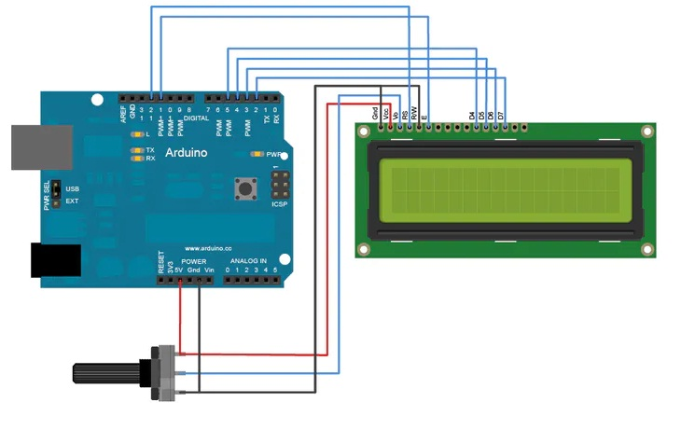

Figure 36: INTERFACING LCD WITH ARDUINO

* RS pin of LCD to digital pin of Arduino
* Enable pin is connected to digital pin of Arduino
* D4 pin is connected to digital pin of Arduino
* D5 pin is connected to digital pin of Arduino
* D6 pin is connected to digital pin of Arduino
* D7 pin is connected to digital pin of Arduino
* Read/Write pin is connected to GND
* VSS pin is connected to the GND terminal
* VCC pin is connected to 5V
* A 220-ohm resistor is connected from LED+ to 5V
* LED is connected to the GND terminal
* In addition, connect a 10k pot toward +5V & GND through its wiper to LCD pin3.

**2.7.7 SPECIFICATIONS**

* The operating voltage of this display ranges from 4.7V to 5.3V
* The display bezel is 72 x 25mm
* The operating current is 1mA without a backlight
* PCB size of the module is 80L x 36W x 10H mm
* HD47780 controller
* LED colour for backlight is green or blue
* Number of columns – 16
* Number of rows – 2
* Number of LCD pins – 16
* Characters – 32
* It works in 4-bit and 8-bit modes
* Pixel box of each character is 5×8 pixel
* Font size of character is 0.125Width x 0.200height

### **2.7.8 ADVANTAGES OF LCD**

* The heat generated during operation is less as compared to CRT and LED display.
* The **power consumption** by an LCD is very less in comparison to other display devices.
* LCDs can be suitably used with MOS integrated circuits.
* The overall cost of the device is low.

### **2.7.9 DISADVANTAGES OF LCD**

* It needs an external source of light for displaying the image.
* Its operating temperature range is limited that lies in between **0 to 60°C**.
* LCDs are **less reliable** display units.
* The image visibility relies on light intensity.

### **2.7.10 APPLICATIONS OF LCD**

* Used in digital wrist watch
* Display images in digital cameras
* Used in numerical counters
* Display screen in calculators
* Mainly used in television
* Used in mobile screens
* Used in video players
* Used in image sensing circuits

**2.8 BUZZER**

**2.8.1 INTRODUCTION**

A buzzer or beeper is an audio signalling device. It generates sound in a frequency range of 1 to 7 kHz as an audio indication. In this frequency range, the hearing threshold is maximum. Therefore, the sound of a buzzer is so piercing that it is noticeable even in a highly noisy environment. The buzzers/beepers are generally used as sound alarms. In many applications, they are used to give an audio indication in response to some action or event. A buzzer can be used to produce the sound of a click, beep, or ringing.

**2.8.2 TYPES OF BUZZERS**

Buzzers come in a variety of construction, size, and specifications. Different types and sizes of buzzers are used for different applications. Based on construction, there are the following kinds of buzzers:

1. Piezoelectric buzzers
2. Magnetic buzzers
3. Electromagnetic buzzers
4. Mechanical buzzers
5. Electromechanical buzzers

Piezoelectric and magnetic buzzers are most commonly used in electronic applications. The buzzers are designed to be used as a transducer or indicator in any circuit.

**2.8.3 PIEZO ELECTRIC BUZZER**

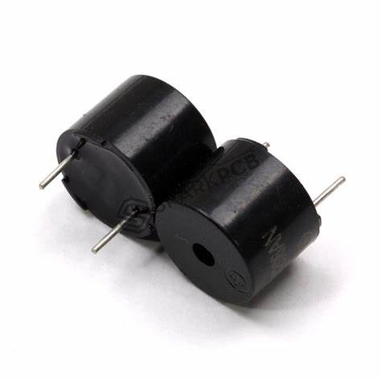

Figure 37: PIEZO ELECTRIC BUZZER

**Piezo buzzer** is an electronic device commonly used to produce sound. Light weight, simple construction and low price make it usable in various applications like car/truck reversing indicator, computers, call bells etc. Piezo buzzer is based on the inverse principle of piezo electricity discovered in 1880 by Jacques and Pierre Curie. It is the phenomena of generating electricity when mechanical pressure is applied to certain materials and the vice versa is also true. Such materials are called piezo electric materials. Piezo electric materials are either naturally available or manmade. Piezoceramic is class of manmade material, which poses piezo electric effect and is widely used to make disc, the heart of piezo buzzer. When subjected to an alternating electric field they stretch or compress, in accordance with the frequency of the signal thereby producing sound.

**2.8.4 WORKING**

A piezoelectric buzzer operates on the principle of the piezoelectric effect. The main component of a piezoelectric buzzer is a piezoelectric element. The element is composed of a piezoelectric ceramic and a metal plate. Both the piezoelectric disc and metal plate are held together with an adhesive. The piezoceramic disc has electrodes attached to it. The piezoelectric disc expands and contracts diametrically when an alternating current is applied to it. This produces vibrations in the piezoelectric element and generating the sound of a particular frequency or range of frequencies.

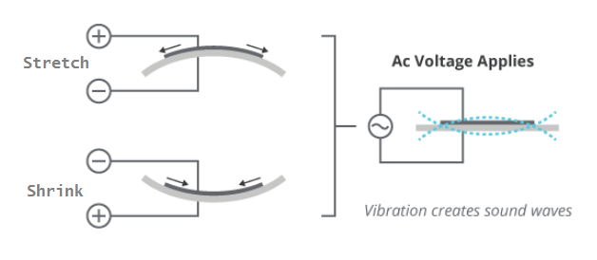

Figure 38: WORKING OF BUZZER

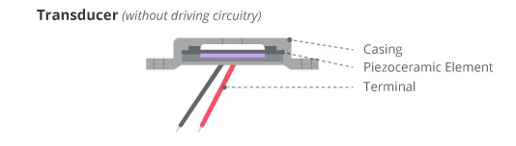

Figure 39: STRUCTURE OF BUZZER

The piezoelectric element is supplied alternating current from an oscillator circuit. In indicator-type piezo buzzers, the oscillator circuit is built-in to produce a fixed frequency or range of frequencies. In transducer type piezo buzzers, an external oscillator circuit is required. This oscillator circuit is usually a square wave generator.

Many piezo buzzers have a feedback line. In such buzzers, the piezoelectric element is divided into two electrically isolated parts. When the main piezo element is actuated, it squeezes the feedback component, producing a feedback voltage. The feedback signal is usually applied to a transistor/OP-AMP circuit, which blocks or amplifies the current supply to the piezoelectric element.

The piezo buzzers have a wide operating voltage that ranges from 3V to 250V. Most of the piezo buzzers used in electronic circuits have an operating voltage between 3V and 12V. These buzzers have high sound pressure levels. They have very low current consumption. Higher is the frequency/tone of the piezo buzzer; the lower is its current consumption. The buzzers used in electronic applications have current consumption as low as 30 mA. The piezo buzzers have a large footprint and are preferred to be used in cost-sensitive electronic applications.

**2.8.5 PIN DESCRIPTION**

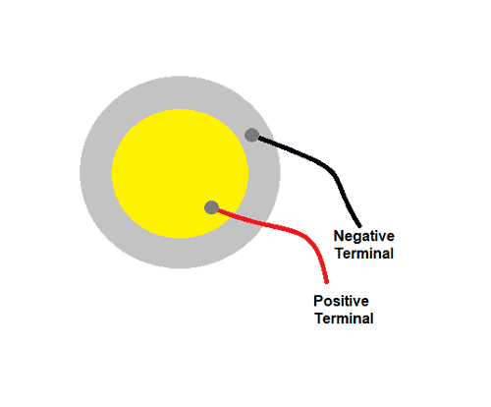

Figure 40: PIN DESCRIPTION OF BUZZER

|  |  |  |
| --- | --- | --- |
| **Pin Name** | **SYMBOL** | **Description** |
| Outer Circle | + VE | This gives Negative output voltage |
| Inner Circle | - VE | This gives positive output voltage |

Table 9: PIN DESCRIPTION OF BUZZER

**2.8.6 SPECIFICATIONS**

* Impedance: ≤500Ω;
* Voltage: ≤30Vp-p;
* Operating temperature: -20°C~+60°C
* Storage temperature: -30°C~+70°C
* Low Soldering temperature
* Strain sensitivity: 5V/µƐ
* Material: Quartz (mostly used)

**2.8.7 APPLICATIONS**

* Production and detection of sound
* Generation of high voltage
* Electronic Frequency generation
* Microbalances
* Ultra-fine focusing of optical assemblies
* Everyday applications like cigarette lighters

**2.9 PUSH BUTTON SWITCH**

**2.9.1 INTRODUCTION**

Push-button switches are open tactile switches that can control a circuit or make a particular action only when you press the button. In other words, it can power up the circuit when pressed and power off the course when released.

Depending on the type of switch, pushbuttons can operate with latching action or momentary action.

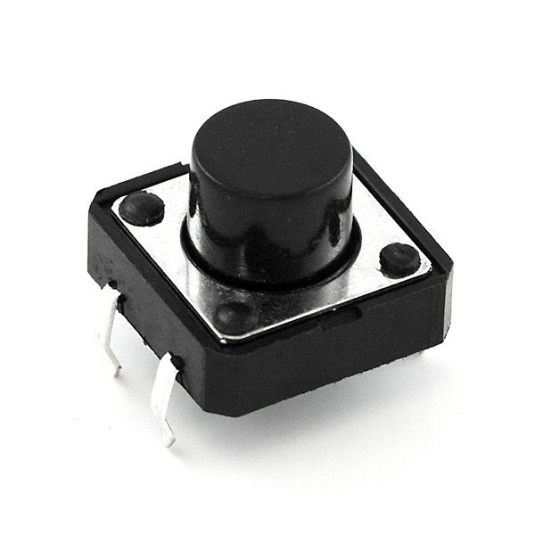

Figure 41: PUSH BUTTON SWITCH

Also, manufacturers would usually build push buttons with solid and durable materials like plastic or metal–so it doesn’t wear out from continuous use.

Additionally, the surface of a pushbutton switch can be either flat or a shape that you can quickly press or depress with your finger.

Furthermore, try not to confuse push button switches with regular switches. While switches have permanent on and off positions, pushbuttons only have temporary on and off functions. Also, when you press a pushbutton switch, it stays in that depressed state until you press it again to release it.

**2.9.2 WORKING**

Push button switches can serve many purposes, but each type operates on a similar principle. When an operator applies pressure to the push button actuator, an internal spring depresses. Contacts attached to the spring connect with the electrical contacts on the switch’s lower end to open or close the electrical circuit. Depending on the switch, releasing the button or pressing it again will retract the spring and return the circuit to its original state.

|  |  |
| --- | --- |
| Figure 42: CLOSED SWITCH | Figure 43: OPEN SWITCH |

The initial state of the push button circuit can be open or closed, depending on the application. The type of switch will also depend on the application.

**2.9.3 TYPES**

Push button switches come in two types: momentary switches or push-pull switches.

* **Momentary.** The momentary push button switch has a single pole and is initially in an off state. When the operator presses the push button switch, it changes to on. There are also double-pole momentary switches that provide an additional state of functionality.
* **Push-pull.** Push-pull switches are typically in an off state until an operator presses the button and engages the actuator. The machine or device will remain on until an operator pulls the actuator to its initial position.

**2.9.4 PIN DESCRIPTION**

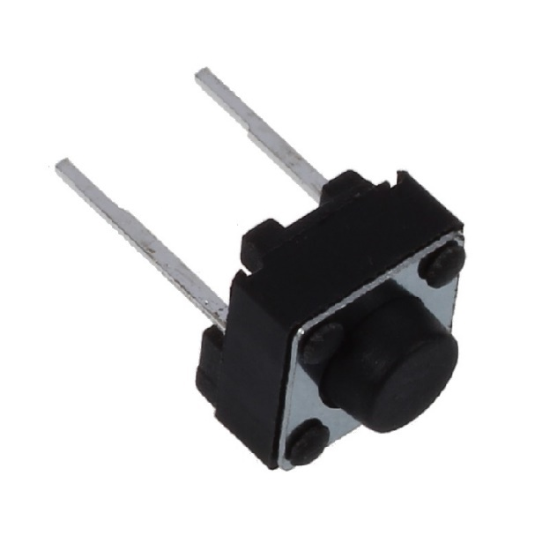

Figure 44: PIN DESCRIPTION OF PUSH BUTTON SWITCH

|  |  |
| --- | --- |
| **TERMINAL** | **Description** |
| + VE | It is negative terminal |
| - VE | It is the positive terminal |

Table 10: PIN DESCRIPTION OF PUSH BUTTON SWITCH

**2.9.5 SPECIFICATIONS**

* It uses a tactile feedback mode of operation
* It has a MAX 50mA 24V DC power rating
* Insulation Resistance: 100Mohm at 100v
* Features a .55±0.69 N operating force
* It has a MAX 100mOhm contact resistance
* Operating Temperature ranges between -20 to +70 ℃
* Storage Temperature ranges between -20 to +70 ℃

**2.9.6 FEATURES**

* It uses a tactile feedback mode of operation
* It has a MAX 50mA 24V DC power rating
* Insulation Resistance: 100Mohm at 100v
* Features a .55±0.69 N operating force
* It has a MAX 100mOhm contact resistance
* Operating Temperature ranges between -20 to +70 ℃
* Storage Temperature ranges between -20 to +70 ℃

**2.9.7 APPLICATIONS**

* Magnetic locks
* Calculators
* Kitchen appliances
* Push-button telephones
* Arcade gaming
* Light switches
* Shower systems and Toilet flushes
* Other mechanical and electronic devices
* Other home and commercial applications

**2.10 BREADBOARD**

**2.10.1 DESCRIPTION**

The term breadboard can be derived from two terms namely bread & board. Initially, this was used to cut the bread into pieces. Further, it was called a breadboard & it was used in electronics projects and electronic devices in the year 1970. A breadboard is also known as a solderless board because the component used on the breadboard does not need any soldering to connect to the board, so it can be reused.

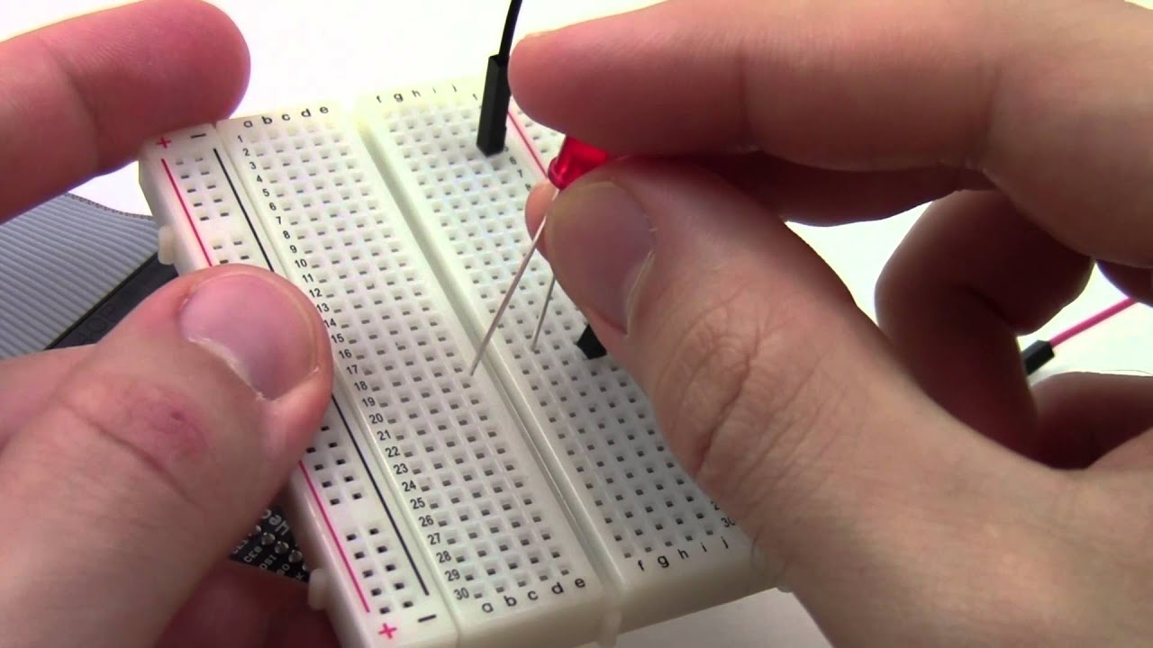

Figure 45: BREADBOARD

The arrangement of different components on a breadboard can be done by inserting their terminals into the breadboard, so it is frequently known as a plugboard. Breadboard definition is a plastic board in rectangular shape that includes a lot of small holes in it to allow you to place different components to build an electronic circuit is known as a breadboard. The connection on the breadboard is not permanent but they can be connected without soldering the components.

If you make any mistake while connecting the components, you can place or remove the components effortlessly. For beginners of electronics, this device is very helpful to make mini-projects. If a designer builds a simple circuit that they desire to analyse, then a breadboard gives a quick solution. The breadboard diagram is shown below.

The material used to make the breadboard is white plastic. At present, most of the breadboards are solderless types, so we can directly plug in the components directly and connected them through the exterior power supply. The different kinds of breadboards are accessible according to the specific point holes. For instance, 400-point type, 830-point type, etc.

**2.10.2 TYPES**

Breadboards are classified into two types like a solderless breadboard and a solder-able breadboard.

#### **Solderless Breadboards**

This is the most commonly used breadboard for prototyping as well as testing electronic circuits without soldering the components. These are available in different shapes, sizes as well as ratings.



Figure 46: SOLDERLESS BREADBOARD

The circuits on these breadboards are not permanent so we can check & test the functionality of a circuit before confirming its design onto a PCB. These breadboards include rows & columns with holes that allow the leads of components & wire gauges.

If the terminal of the component does not place into the hole of a breadboard, then a connecting wire can be soldered to the lead of a component that will insert in the breadboard hole.

**Solderable Breadboards**

These types of breadboards offer a permanent setup for your electronic circuits. This kind of breadboard gives a stronger setup. It includes holes for electronic components including copper tracing. These components can be soldered using soldering iron for soldering the components to the breadboard so that an electrical connection can be formed through the copper tracing.



Figure 47: SOLDERABLE BREADBOARD

For designing a circuit, jumper wires are needed for soldering separately in between these components to make a lane to permit the flow of current. These types of breadboards are available in different sizes based on the requirement.

**2.10.3 SPECIFICATIONS**

* Distribution Strips are two
* Wire Size is 21 to 26 AWG wire
* Tie Points are two hundred
* Withstanding Voltage is 1,000V AC
* Tie points within IC are 630
* Insulation Resistance is DC500V or 500MΩ
* Dimension is 6.5*4.4*0.3 inch
* Rating is 5Amps
* ABS plastic through colour legend
* ABS heat Distortion Temperature is 183° F (84° C) Hole or Pitch Style is 2.54mm

**2.10.4 ADVANTAGES**

* It is used to make a temporary prototype for the electronics projects
* This is reusable because it doesn’t need any soldering.
* These boards are less weight because the material used to make this board is a lightweight plastic material.
* Testing can be done very easily
* The arrangement of these components can be done very simply into the holes on the board to make the design of a circuit.
* It is economical and simple to use
* It does not use any difficult parts.
* Drilling is not necessary to connect the components because the holes on the board are embedded already
* Modifying can be done very quickly
* We can add or remove the components on the breadboard
* These boards are available in different sizes and shapes
* These boards can be adjusted very easily

**2.10.5 DISADVANTAGES**

* These boards are not used for high current applications
* For low-frequency applications, low-frequency boards are not used
* For making simple circuits, it needs more physical space.
* The number of connections on the breadboard can make the circuit messy because of several wires.
* The connections on the board can be disturbed once the components are connected or removed.
* Reliable connections are less
* Signalling is limited.

#### **2.10.6 SAFETY TIPS FOR BREADBOARD**

It is very important to connect a circuit systematically & neatly on a breadboard so that one can correct it & get it running simply & rapidly. It also assists once someone else requires knowing and inspecting the circuit. The following tips are very useful for breadboard.

* Use the top & bottom bus rails always for connecting power supply instead of using a direct power supply
* When the jumper wires are coded with colour then it will help in reducing the confusion while designing a circuit. For instance, green colour wires are used for GND connections, red colour wire for +Ve power whereas black colour one is for -Ve power connections.
* Jumper wires should be connected lay flat on the board so that the board does not turn cluttered.
* Connect the jumper wires in the region of the ICs but not on the packages so that IC can be changed easily when required.
* Cutting the components leads can lead to insert very closely to the board.
* Be careful when connecting components
* It is significant to be particularly careful while placing ICs into the holes of the board.
* Power supply terminals should not connect otherwise it may cause a short circuit.
* Once the board is connected to the power supply, do not leave it alone
* Do not stroke the IC elements with uncovered hands once the circuit supplies through it because they are sensitive components, so there is a chance to get damage.
* Once the power supply is given to the board, do not connect or remove components
* It is necessary to monitor exact polarity once certain components are connected to the circuit, otherwise, that may break down the dielectric within the component
* If water or liquid dropped onto the board, then right away remove it from the power supply.
* Maintain your surroundings clean and in sequence

**2.10.7 APPLICATIONS**

* The main application of a breadboard is to form simple electrical connections among different components so that you can check your circuit before soldering it to the board.
* These boards allow different components to be simply placed or removed or the term prototyping instantly comes to mind permanently.
* If a designer designs a simple circuit or module then they need to check, so this board offers a fast & cheap solution

**2.11 9V BATTERY**

**2.11.1 DESCRIPTION**

#### The 9V battery is an extremely common battery that was first used in transistor radios. It features a rectangular prism shape that utilizes a pair of snap connectors which are located at the top of the battery. A wide array of both large and small battery manufacturers produces versions of the 9V battery. Possible chemistries of primary (non-rechargeable) 9V batteries include Alkaline, Carbon-Zinc (Heavy Duty), Lithium. Possible chemistries of secondary (rechargeable) 9V batteries include nickel-cadmium (NiCd), nickel-metal hydride (NiMH), and lithium ion. The performance and application of the battery can vary greatly between different chemistries, meaning that some chemistries are better suited for some applications over others.

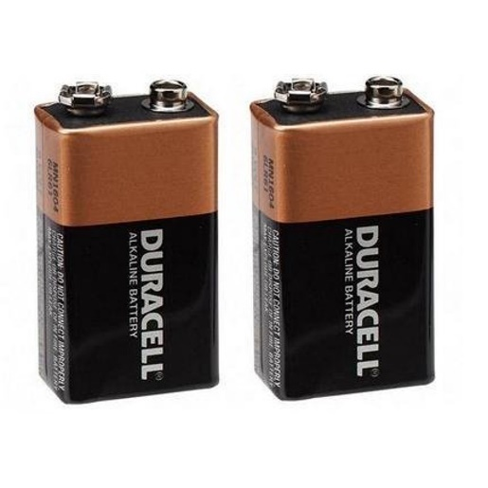

Figure 48: 9V BATTERY

#### The typical shelf life (storage in good condition) of an alkaline 9V battery will typically be about 10 years. The service life of a 9V battery can depend on a variety of factors. Most importantly it is determined by the chemistry/quality of the battery and the load you are putting it under. Applications that require a mild energy use, using a high-quality battery can see battery life of up to 5 years. More demanding applications and adverse environmental conditions like heat and moisture can result in a shortening of battery service life.



Figure 49: SYMBOL OF BATTERY

**2.11.2 ABOUT BATTERY CONNECTOR**

The 9v Battery Snap Connector with DC Jack with Battery Connector Cap is widely used for project purposes. The 9V Battery Snap Connector with Power Plug provides the ability to conveniently use a 9V battery to power many common boards and modules such as the popular Arduino and compatible microcontrollers.

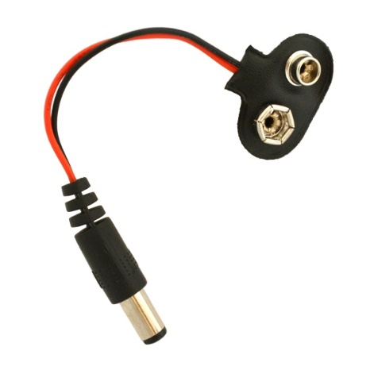

Figure 50: BATTERY CONNECTOR

This plug is a very common barrel type with an outside diameter of 5.5mm and an inside diameter of 2.1mm. The centre is positive.

**2.11.3 SPECIFICATIONS:**

|  |  |
| --- | --- |
| **9V Battery Nominal Voltage:** | **9 Volts** |
| **Capacity (Alkaline) ≈** | **550 mAh** |
| **Capacity (Carbon-Zinc) ≈** | **400 mAh** |
| **Capacity (Lithium Primary) ≈** | **1200 mAh** |
| **Capacity (NiMH) ≈** | **175-300mAh** |
| **Operating Temperature:** | **0°C – 60°C** |
| **Length:** | **17.5 mm** |
| **Height:** | **48.5 mm** |
| **Width:** | **26.5 mm** |
| **Chemistry:** | **Alkaline, Lithium, Carbon-Zinc, NiCd, NiMH, Lithium-Ion** |

Table 11: SPECIFICATIONS OF BATTERY

**2.11.4 SAFETY PRECAUTIONS:**

* Do not put it beside the high-temperature condition.
* Don’t throw it into the fire or Water after use

**2.11.5 FEATURES:**

* Constant 9V Output till lasts
* Metal Jacket Body
* Good Built Quality and hence Leakproof
* Easy to install and Replace
* Corrosion free Connector Point for long-term use
* 0% Mercury and Cadmium. Environment-friendly
* OEM Compatible

**2.12 JUMPER WIRES**

**2.12.1 DESCRIPTION**

A jump wire (also known as jumper wire, or jumper) is an electrical wire, or group of them in a cable, with a connector or pin at each end (or sometimes without them – simply "tinned"), which is normally used to interconnect the components of a breadboard or other prototype or test circuit, internally or with other equipment or components, without soldering.

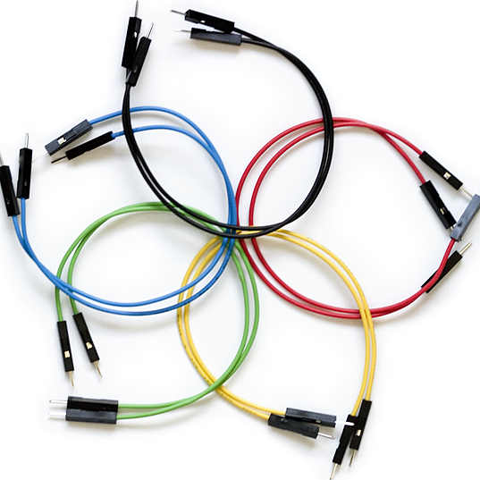

Figure 51: JUMPER WIRES

Individual jump wires are fitted by inserting their "end connectors" into the slots provided in a breadboard, the header connector of a circuit board, or a piece of test equipment.

### **2.12.2 Types**

Jumper wires at the end of a multi-coloured ribbon cable are used to connect the pin header at the left side of a blue USB2Serial board to a white breadboard below. Another jumper cable ending in a USB micro male connector mate to the right side of the USB2Serial board. Red and black tinned jump wires can be seen on the breadboard.

There are different types of jumper wires. Some have the same type of electrical connector at both ends, while others have different connectors. Some common connectors are:

1. **Solid tips** – are used to connect on/with a breadboard or female header connector. The arrangement of the elements and ease of insertion on a breadboard allows increasing the mounting density of both components and jump wires without fear of short-circuits. The jump wires vary in size and colour to distinguish the different working signals.
2. **Crocodile clips** – are used, among other applications, to temporarily bridge sensors, buttons and other elements of prototypes with components or equipment that have arbitrary connectors, wires, screw terminals, etc.

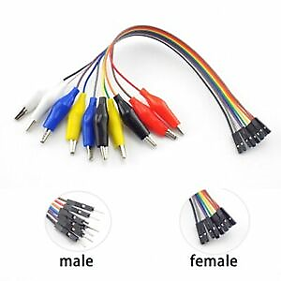

Figure 52: TYPES OF JUMPER WIRES

1. **Banana connectors** – are commonly used on test equipment for DC and low-frequency AC signals.
2. **Registered jack (RJnn)** – are commonly used in telephone (RJ11) and computer networking (RJ45).

Which is used to connect antennas and other components to network cabling. Jumpers are also used in base stations to connect antennas to radio units. Usually, the most bendable jumper cable diameter is 1/2"RCA connectors – are often used for audio, low resolution composite video signals, or other low-frequency applications requiring a shielded cable.

1. **RF connectors** – are used to carry radio frequency signals between circuits, test equipment, and antennas.

RF jumper cables Jumper cables is a smaller and more bendable corrugated cable.

1. **Male connectors** – A connector type with pins instead of holes. These connectors are inserted into a female connector. Good examples of male connectors are power plugs and coaxial cables. In the example picture, the power cord connector on the left-side with holes is a female connector, and on the right-side with pins that connects to the wall outlet is a male connector.
2. **Female connector** – A female connector is a connector attached to a wire, cable, or piece of hardware, having one or more recessed holes with electrical terminals inside, and constructed in such a way that a plug with exposed conductors (male connector) can be inserted snugly into it to ensure a reliable physical and electrical connection. A female connector is also known as a jack, outlet, or receptacle. This type of connector can be recognized by the fact that, when it is disconnected therefore are not likely to make accidental contact with external objects or conductors. The most common female connector is a two- or three-prong electrical outlet, also known as a wall outlet. Other often-encountered examples include telephone jacks, the jacks for headsets, the chassis connectors for coaxial cable, and some D-shell connectors for computer serial and parallel ports.

**2.12.3 Advantages**

* Low cost.
* Perfect for Prototyping and testing small circuits.
* Perfect for all who are starting with Electronics.
* You can change the circuit at any time

# **2.13 I2C Serial Interface Adapter Module for LCD**

**2.13.1 DESCRIPTION**

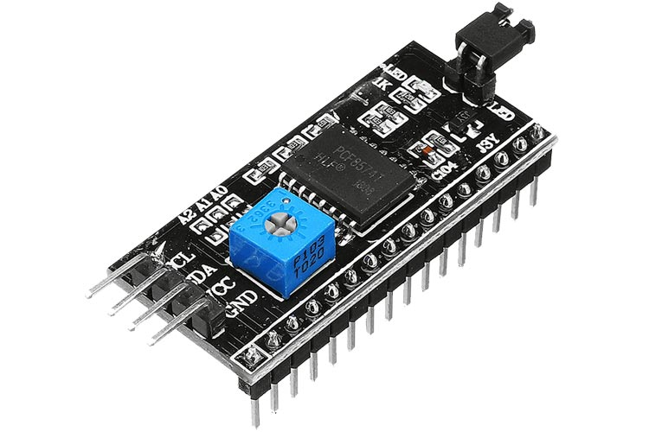

Figure 53: I2C MODULE FOR LCD

Due to limited pin resources in a microcontroller/microprocessor, controlling an LCD panel could be tedious. Serial to Parallel adapters such as the I2C serial interface adapter module with PCF8574 chip makes the work easy with just two pins. The serial interface adapter can be connected to a 16x2 LCD and provides two signal output pins (SDA and SCL) which can be used to communicate with an MCU/MPU.

**2.13.2 PIN DESCRIPTION**

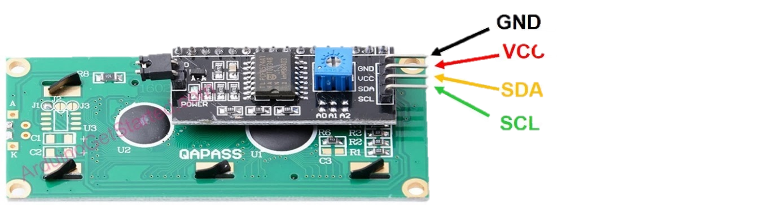

Figure 54: PIN DESCRIPTION OF IIC

|  |  |  |
| --- | --- | --- |
| **Pin Name** | **Pin Type** | **Pin Description** |
| GND | Power | Ground |
| VCC | Power | Voltage Input |
| SDA | I2C Data | Serial Data |
| SCL | I2C Clock | Serial Clock |

Table 12: PIN DESCRIPTION OF I2C MODULE

### **2.13.3 CONNECTING I2C SERIAL INTERFACE ADAPTER MODULE TO AN MICROCONTROLLER**

The I2C serial adapter can be connected to 16x2 or 20x4 LCD displays via breakout pins. Once it fits perfectly onto the LCD, we can connect the module to any MCU/MPU using I2C protocol pins.

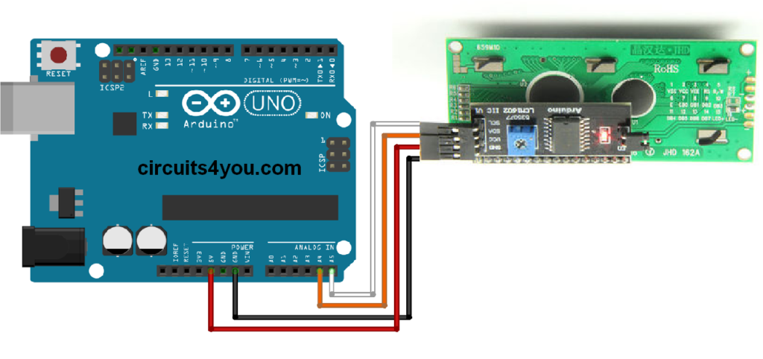

Table 55: INTERFACING I2C LCD WITH ARDUINO

The power points VCC and GND can be connected to the 5V and the ground terminal of the MCU/MPU, respectively. Also, connect the SDA, SCL pins of the module to the MCU/MPU I2C pins respectively to send the data.

**2.13.4 APPLICATIONS**

* Serial to parallel data adapter
* Robots
* LCD Displays

**CHAPTER – 3**

**SOFTWARE DESCRIPTION**

**CHAPTER-3.1: ARDUINO SOFTWARE**

**3.1.1 Installing Arduino IDE**

Firstly, we must have our Arduino board and USB cable. As we are using Arduino Nano, we should use a Mini-B USB 2.0 cable to connect the board to the computer. The below figure shows the Mini-B USB 2.0 cable.

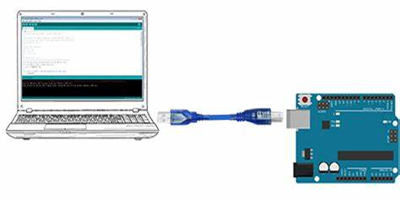

Figure 56: INSTALLING THE ARDUINO IDE - I

You can get different versions of Arduino IDE from the Download page on the Arduino Official website. You must select your software, which is compatible with your operating system (Windows, IOS, or Linux). After your file download is complete, unzip the file.

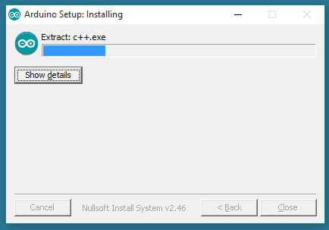

Figure 57: INSTALLING OF ARDUINO IDE - II

**3.1.2 Creating New Project**

**>**First open the Arduino IDE

* Select File > New > the new project will open

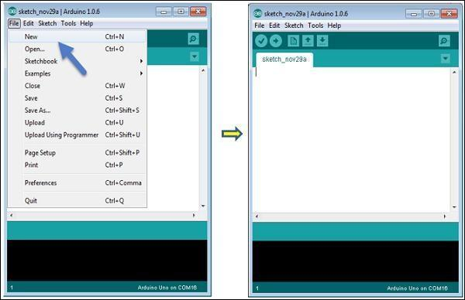

Figure 58: CREATING NEW PROJECT ON ARDUINO IDE

**3.1.3 Adding the ESP8266 path to Arduino preferences**

* Click on file > Preferences
* Add the link given below on the field of additional boards manager URL’s

***http://arduino.esp8266.com/stable/package_esp8266com_index.json***

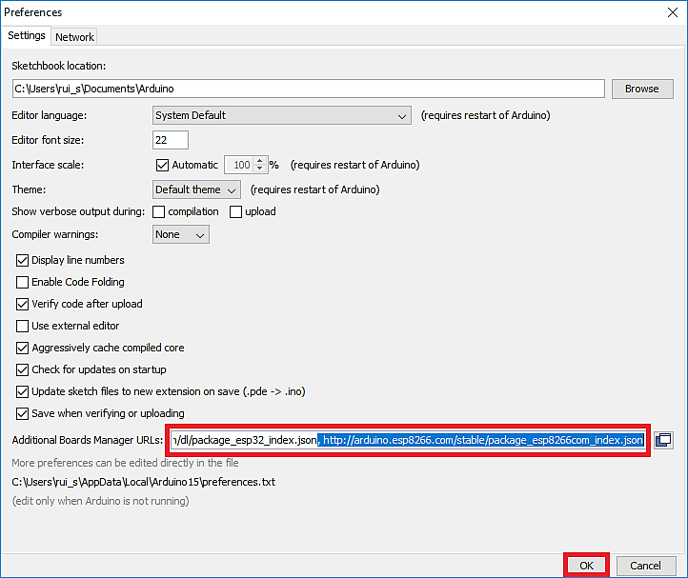

Figure 59: ADDING PATH TO PREFERENCES

**3.1.4 Downloading the ESP8266 board**

* Click on tools > boards > boards manager
* A window will get open.
* Search “ESP8266” and Install the ESP8266 board.

.



Figure 60: DOWNLOADING THE BOARD IN IDE

**3.1.5 Board Selection**

* To avoid any error while uploading your program to the board, you must select the correct board name, which matches with the board connected to your computer.
* Go to Tools → Board and select your board.

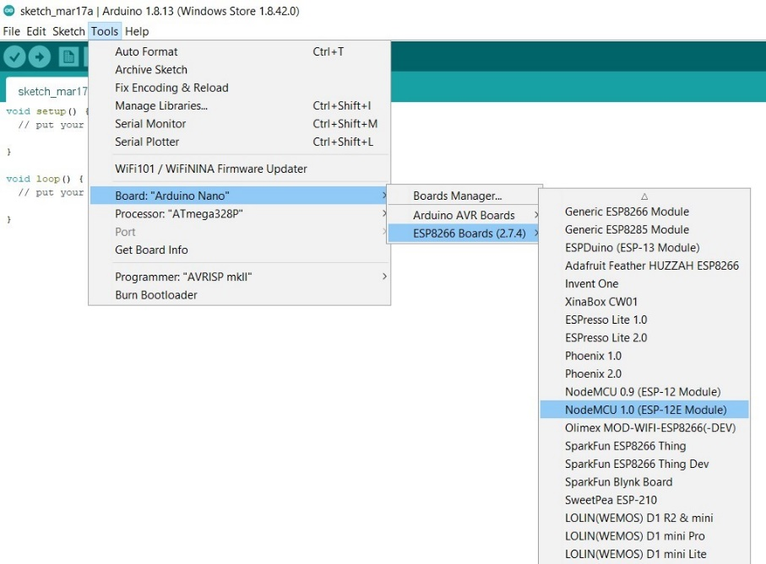

Figure 61: BOARD SELECTION ON ARDUINO IDE

**3.1.6 Port Selection**

* Go to Tools → Serial Port menu.
* This is likely to be COM3 or higher (COM1 and COM2 are usually reserved for hardware serial ports).
* To find out, you can disconnect your Arduino board and re-open the menu, the entry that disappears should be of the Arduino board. Reconnect the board and select that serial port

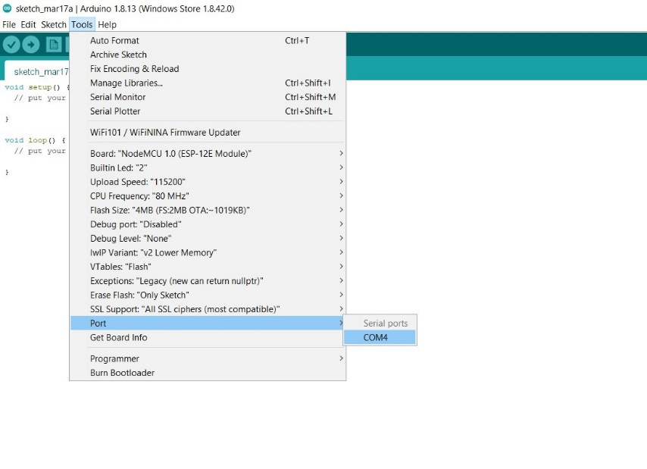

Figure 62: PORT SELECTION ON ARDUINO IDE

**3.1.7 Compiling, Saving and Uploading the Program**

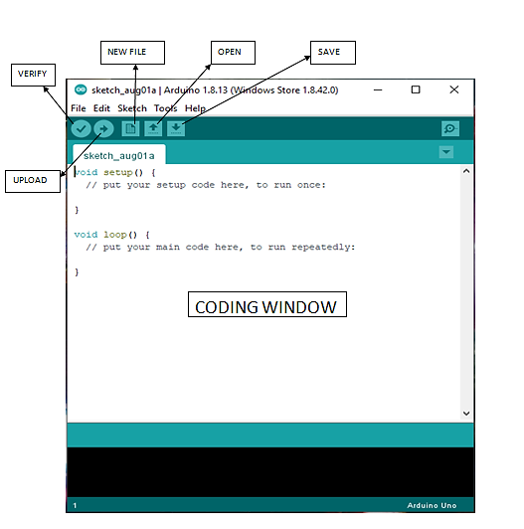

Figure 63: BASIC TOOLS IN ARDUINO IDE

* Compiling is used to detect the errors in the program.
* Saving is used to save the program for future use.
* Upload is used to upload the program to the board.

**CHAPTER-3.2: THINGER.IO**

**3.2.1 Introduction**

Thinger.io platform is formed by two main products a Backend (which is the actual IoT server) and a web-based Frontend that simplifies working with all the features using any computer or smartphone. The image below shows the main features provides by this platform to create IoT projects.

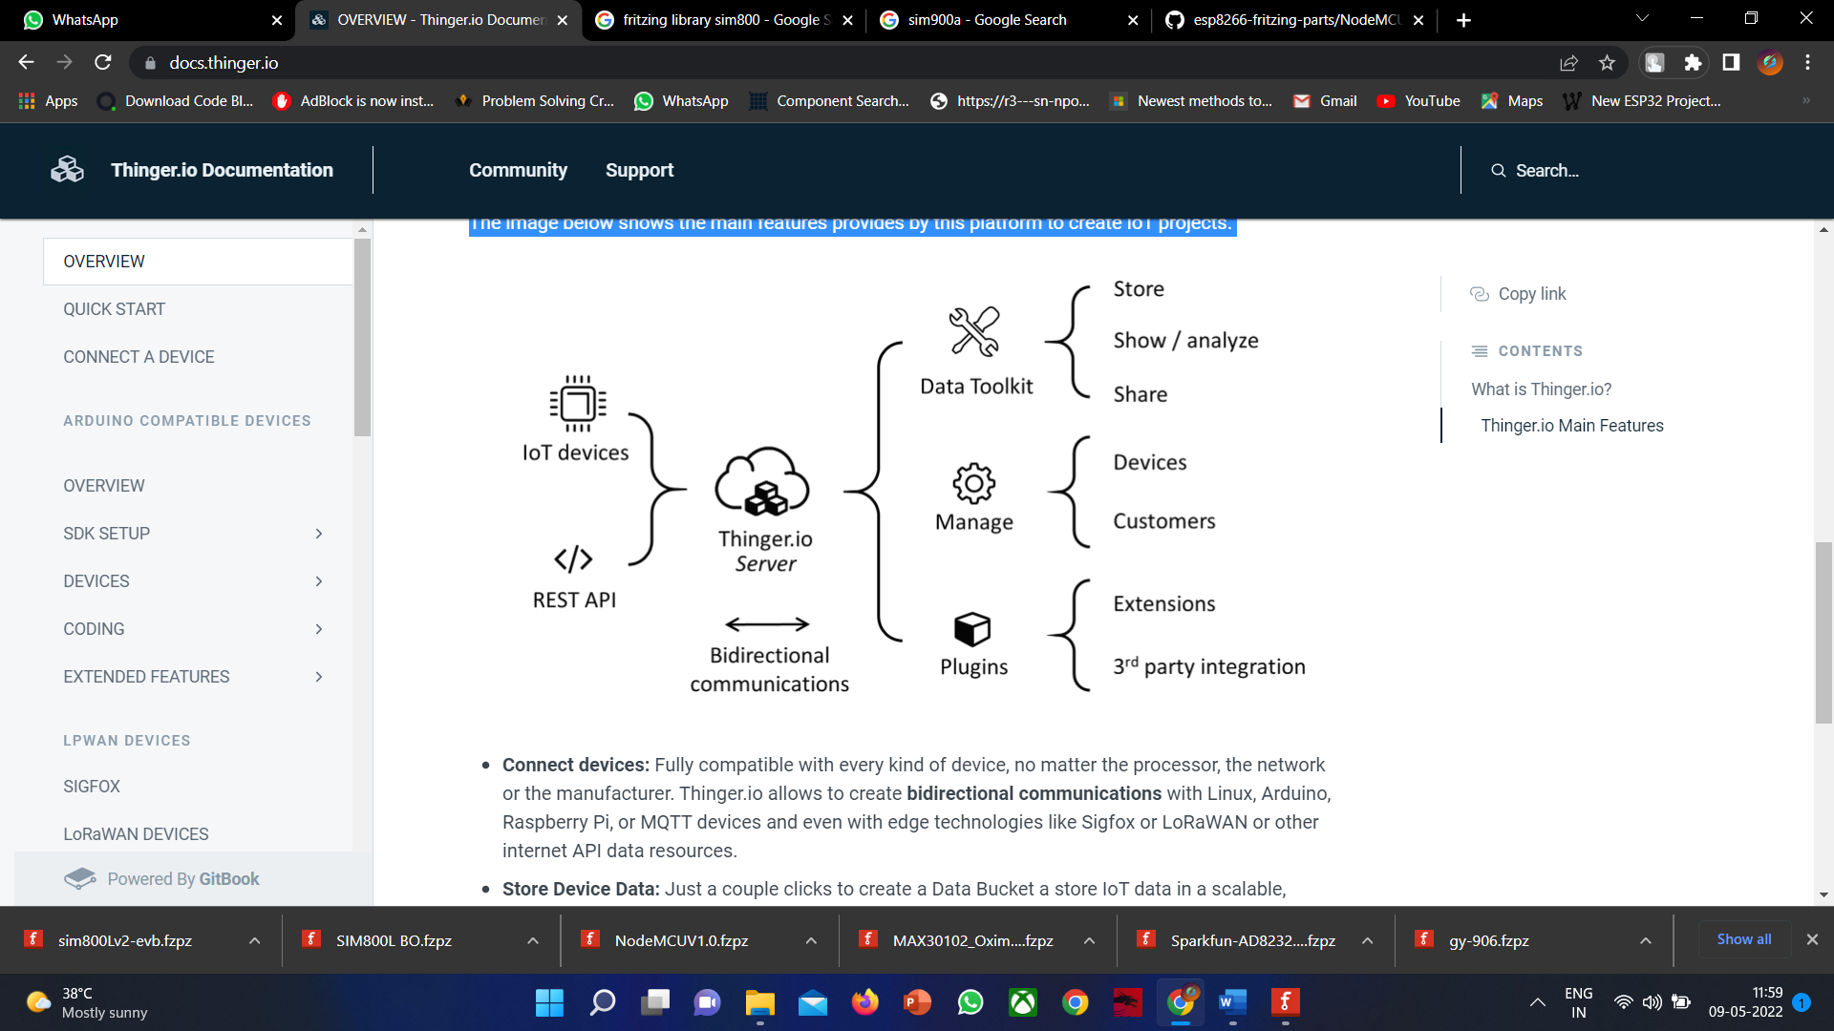

Figure 61: Thinger.io

* **Connect devices:** Fully compatible with every kind of device, no matter the processor, the network or the manufacturer. Thinger.io allows to create bidirectional communications with Linux, Arduino, Raspberry Pi, or MQTT devices and even with edge technologies like Sigfox or Lora WAN or other internet API data resources.
* **Store Device Data:** Just a couple clicks to create a Data Bucket a store IoT data in a scalable, efficient and affordable way, that also allows real-time data aggregation.
* **Display Real-time** or Stored Datain multiple widgets such as time series, donut charts, gauges, or even custom-made representations to create awesome dashboards within minutes.
* **Trigger events and data values** using an embedded Node-RED rule engine
* **Extend with custom features** with multiple plugins to integrate IoT projects into your company's software or any other third-party Internet service.
* **Custom the appearance** thanks to our fully rebrand able frontend, that allows introducing your branding colours, logotypes and web domain

**3.2.2 CREATING ACCOUNT IN THINGER.IO**

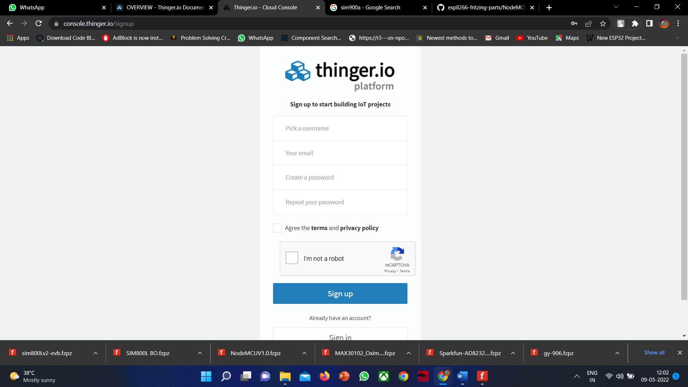

Figure 65: CREATING ACCOUNT IN THINGER

* Create an account in thinger.io by opening thinger.io site in a browser and input the valid email and register the details
* And complete the creation of the account and proceed to the next process.

**3.2.3 CREATING DEVICE IN THINGER.IO**

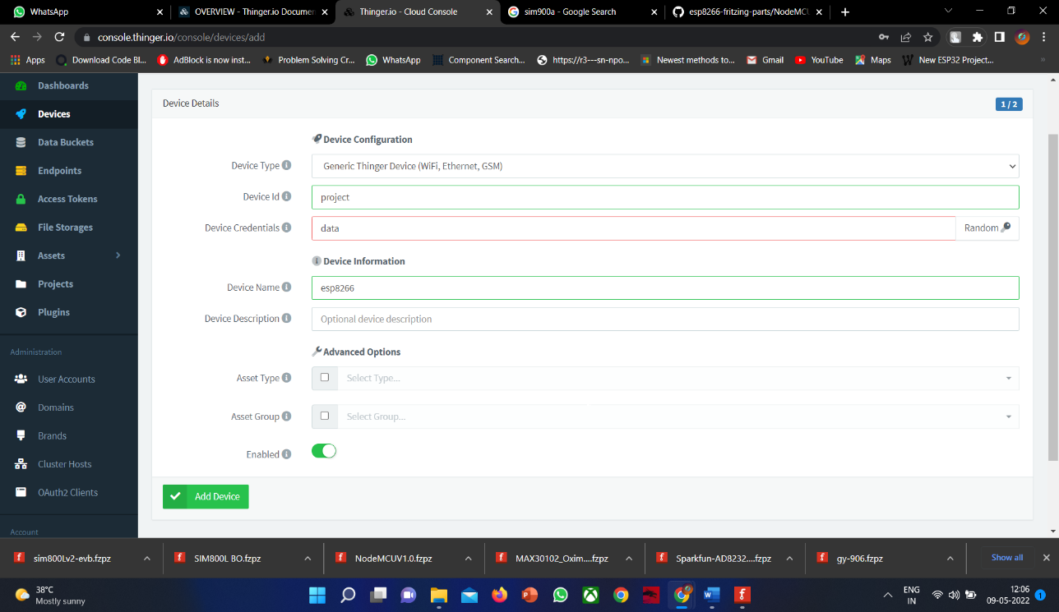

Figure 66: CREATING DEVICE IN THINGER

* To create a device in thinger.io just after login just click on the devices in the home page of the website
* Then click on add a new device and this opens and enter the fields required as we are using esp8266 only select GENERIC THINGER DEVICE (WIFI, Ethernet, GSM);
* Then click on add device
* Your devide will be created with the following details you entered the page will be redirected to a page of the device as follows

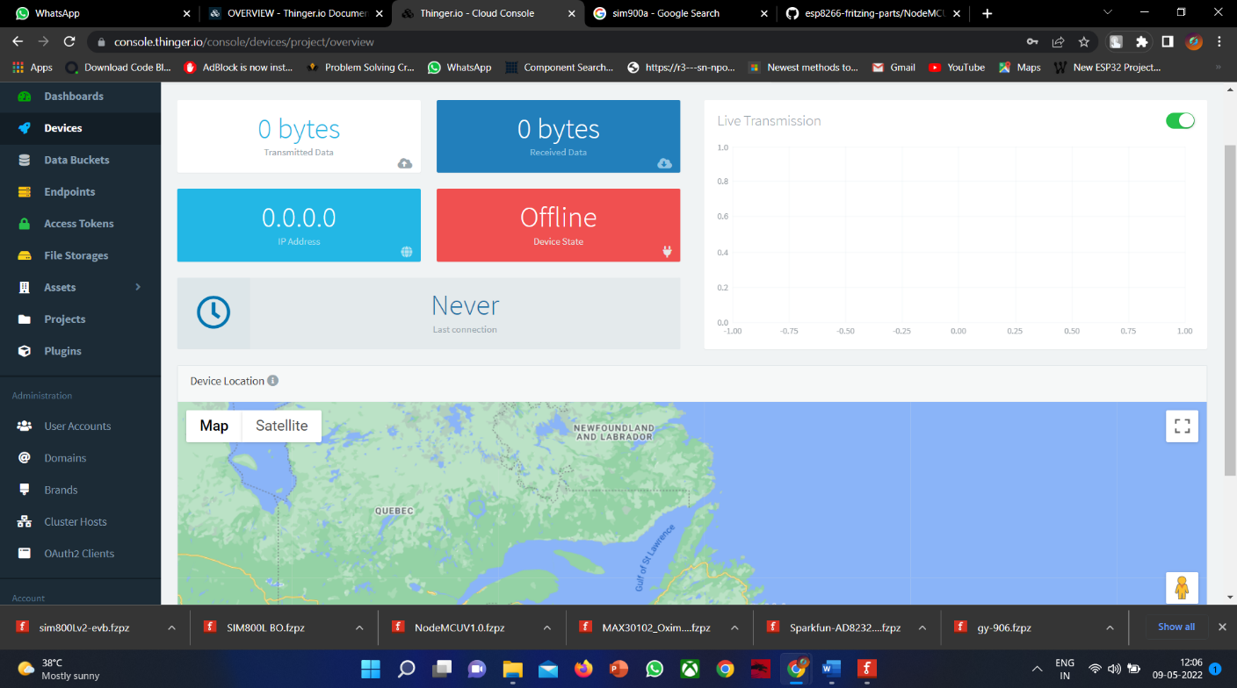

Figure 67: SHOWING LIST OF DEVICES

**3.2.4 CREATING DASHBOARD IN THINGER.IO**

* Click on dashboard in the home page of the thinger.io website
* Now click on new dashboard
* Now a window opens asking for a all the details of the dashboard

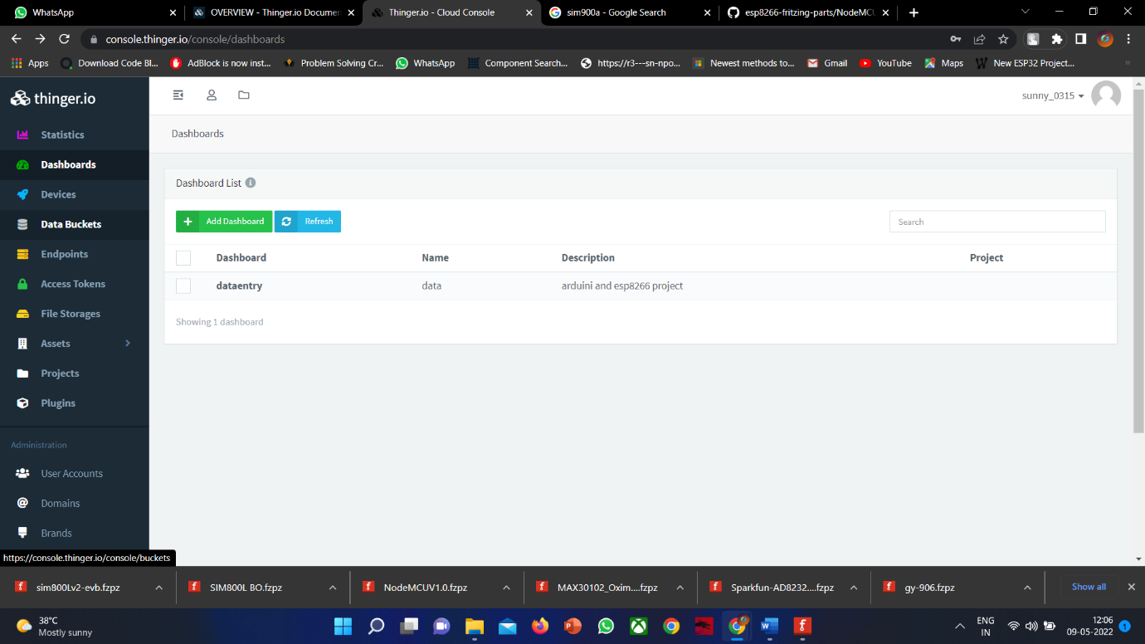

Figure 68: DASHBOARD OF THINGER

* Now click on the dashboard you created and it opens and now add a widget according to the need

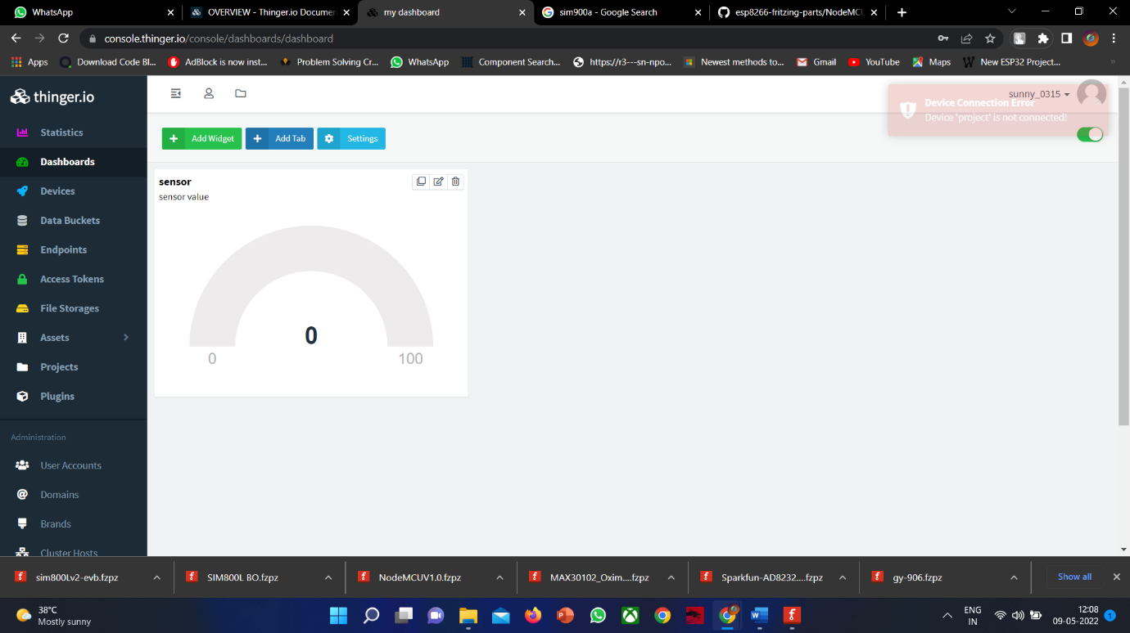

Figure 69: DASHBOARD SHOWING REAL TIME VALUES IN THINGER

* The values can be displayed and viewed in real time from the website every second

**CHAPTER – 4**

**ABOUT PROJECT**

**CHAPTER - 4.1: BLOCK DIAGRAM**

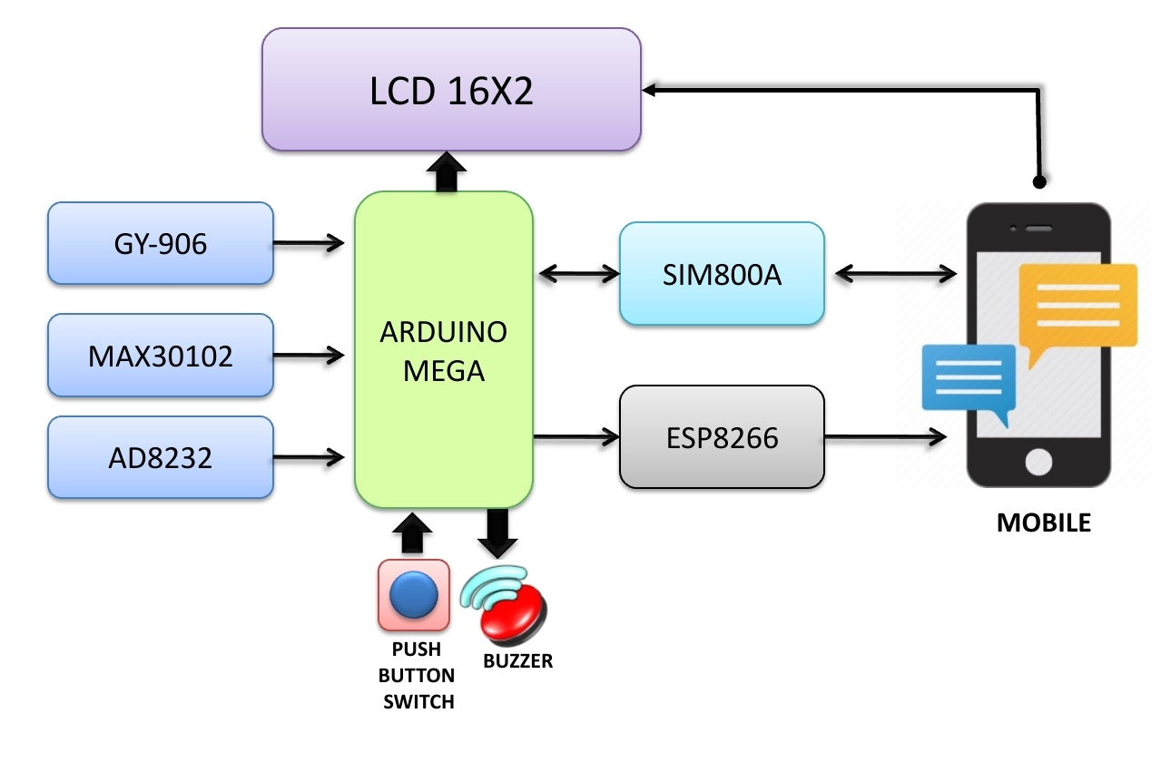

Figure 70: BLOCK DIAGRAM OF PROJECT

This is the block diagram of our project “**IoT based Health Monitoring System**”, which consists of some main blocks like Arduino Mega, ESP8266, MAX30100, AD8232, GY906, SIM800A, AD8232.

These blocks are very useful to transmit the data to doctor’s mobile and receive the reply prescription from doctor about patients’ health.

Here some blocks like LCD16X2, Buzzer and Switch is used as indicators for patient and their guardians. The lcd is used to display the health readings of patients in real-time and buzzer rings when we get any message from doctor and when we press the push button switch a message will sent to guardian as meet the patient immediately – he needs any help.

**Arduino Mega**

The Arduino Mega is a microcontroller board based on the ATmega1280. It has 54 digital input/output pins (of which 14 can be used as PWM outputs), 16 analog inputs, 4 UARTs (hardware serial ports), a 16 MHz crystal oscillator, a USB connection, a power jack, an ICSP header, and a reset button. It contains everything needed to support the microcontroller; simply connect it to a computer with a USB cable or power it with a AC-to-DC adapter or battery to get started. The Mega is compatible with most shields designed for the Arduino Duemilanove or Diecimila.

**ESP8266**

The NodeMCU is an open-source software and hardware development environment built around an inexpensive System-on-a-Chip (SoC) called the ESP8266. The ESP8266, designed and manufactured by Espressif Systems, contains the crucial elements of a computer: CPU, RAM, networking (WiFi), and even a modern operating system and SDK. That makes it an excellent choice for Internet of Things (IoT) projects of all kinds.

However, as a chip, the ESP8266 is also hard to access and use. You must solder wires, with the appropriate analog voltage, to its pins for the simplest tasks such as powering it on or sending a keystroke to the “computer” on the chip. You also have to program it in low-level machine instructions that can be interpreted by the chip hardware. This level of integration is not a problem using the ESP8266 as an embedded controller chip in mass-produced electronics. It is a huge burden for hobbyists, hackers, or students who want to experiment with it in their own IoT projects.

**MAX30100**

**MAX30100** is a Pulse Oximeter and Heart-Rate Sensor IC which is used to check the health of a person with any condition that affects blood oxygen levels, such as Heart Attack, Heart failure, Lungs Cancer Asthma, etc. The MAX30100 operates from 1.8V and 3.3V power supplies and can be powered down through software with negligible standby current, permitting the power supply to remain connected at all times. The sensor comprises two Light Emitting Diodes, a photodetector, and a series of low noise signal processing devices to detect heart rate and to perform pulse oximetry.

**AD8232**

The AD8232 Single Lead Heart Rate Monitor is used to measure the electrical activity of the heart. This electrical activity can be charted as an ECG or Electrocardiogram and output as an analog reading.

ECGs can be extremely noisy, the AD8232 Single Lead Heart Rate Monitor acts as an op amp to help obtain a clear signal from the PR and QT Intervals easily. The AD8232 is an integrated signal conditioning block for ECG and other biopotential measurement applications. It is designed to extract, amplify, and filter small biopotential signals in the presence of noisy conditions, such as those created by motion or remote electrode placement.

The AD8232 Heart Rate Monitor breaks out nine connections from the IC that you can solder pins, wires, or other connectors to. SDN, LO+, LO-, OUTPUT, 3.3V, GND provide essential pins for operating this monitor with an Arduino or other development board. Also provided on this board are RA (Right Arm), LA (Left Arm), and RL (Right Leg) pins to attach and use your own custom sensors. Additionally, there is an LED indicator light that will pulsate to the rhythm of a heartbeat.

**GY906**

The GY906 is a Contactless Infrared (IR) Digital Temperature Sensorthat can be used to measure the temperature of a particular object ranging from -70° C to 382.2°C. The sensor uses IR rays to measure the temperature of the object without any physical contact and communicates to the microcontroller using the I2C protocol.

**SIM800A**

The SIM800A Quad-Band GSM/GPRS Module with RS232 Interface is a complete Quad-band GSM/GPRS solution in an LGA (Land grid array) type which can be embedded in the customer applications. SIM800A support Quad-band 850/900/1800/1900 MHz, it can transmit Voice, SMS and data information with low power consumption.

With a tiny size, it can fit into slim and compact demands of custom design. Featuring and Embedded AT, it allows total cost savings and fast time-to-market for customer applications.

The SIM800A modem has a SIM800A GSM chip and RS232 interface while enables easy connection with the computer or laptop using the USB to the Serial connector or to the micro-controller using the RS232 to TTL converter. Once you connect the SIM800A modem using the USB to RS232 connector, you need to find the correct COM port from the Device Manager of the USB to Serial Adapter.

Then you can open Putty or any other terminal software and open a connection to that COM port at 9600 baud rate, which is the default baud rate of this modem. Once a serial connection is open through the computer or your micro-controller you can start sending the AT commands. When you send AT commands for example “AT\r” you should receive back a reply from the SIM800A modem saying “OK” or other response depending on the command sent.

These blocks are to record the health readings of patient and to display it on lcd and website, where we use the esp8266 module to upload the health readings to website in real-time manner.

Here in this project, we are monitoring the health readings like heart rate, body temperature, ecg readings and SPO2 levels. That readings are collected using sensors like max30100, ad8232, gy906 etc.

Using these readings of patient, we can control and monitor the covid causing situations and the covid cases in our world can gradually decrease by using these readings.

**CHAPTER – 4.2: CIRCUIT DIAGRAM**

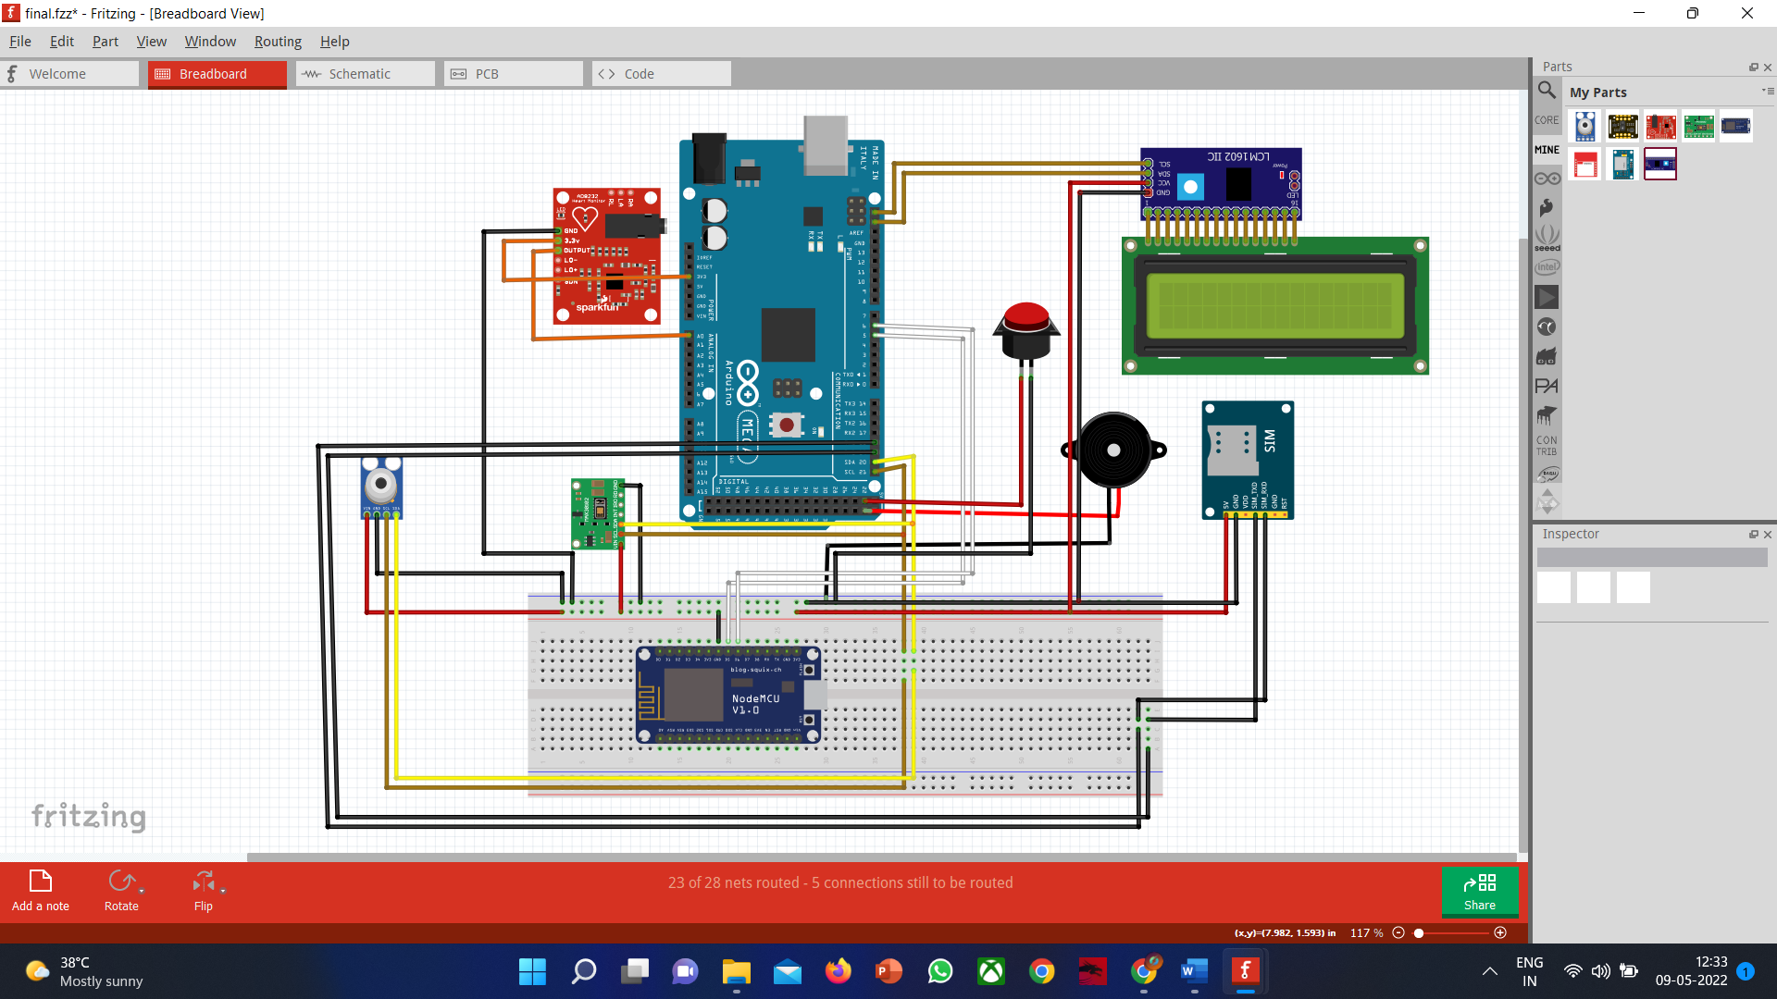

Figure 71: CIRCUIT DIAGRAM OF PROJECT

**CONSTRUCTION**

In the circuit diagram of our project, we have used some most useful sensors like NodeMCU, Arduino mega, SIM800A, GY906, MAX30100, AD8232, LCD 16x2, Push Button Switch and Buzzer.

The main microcontroller which is used in this project is Arduino mega which helps to communicate between 2 devices and here the sensors are interfaced with microcontroller to send the data to display on lcd and send to website.

The Arduino mega has 54 digital pins and 16 analog pins which helps to connect to different modules for different uses. It has 6 power pins where it has 5v and 3.3v and ground pins which is used to provide the power to sensors whichever we need. It has 2 sets of SDA and SCL pins which is useful for IIC communication over sensors. The sensors which support I2C communication can easily send or receive data via serial communication with these pins. There are 3 sensors which supports the IIC communication in our project i.e., GY906, MAX30100 and LCD16x2.

Here we are using IIC interface to LCD16x2 to use the lcd with low connecting wires and with more accurate display. This helps lcd to work with SCL and SDA pins which is a serial data and serial clock pins which provides the lcd for serial communication.

**CONNECTIONS**

The components of our project have serial communication support means it has SCL and SDA pins so the SCL and SDA pins of GY906, MAX30100, I2C LCD are connected to the common pins of SCL and SDA of arduino mega. The VCC and GND of every component is connected to 5V of arduino mega and the VCC pin of MAX30100 and AD8232 is connected to 3.3V pin of arduino mega because the MAX30100 and AD8232 supports the 3.3v as input.

The SIM800A module has TXD and RXD pins is connected to RXD to TXD pins of arduino mega. The module AD8232 has output pin connected to A0 pin of arduino mega which gives the analog output and the LO- and LO+ pins are connected to digital pins of arduino mega.

The components buzzer and push button switch have 1 ground pin and 1 vcc pin which is connected to digital pin of arduino mega. The D4 pin of NodeMCU is connected to 4th pin of arduino and D5 pin of NodeMCU is connected to 5th pin of arduino and GND is connected to GND of arduino.

By connecting the components like this given way can make the project work properly.

**WORKING**

* The values from sensor’s - gy-906, ad8232, max30102 is displayed at lcd. Here gy906 gives the temperature readings, max30102 gives SPO2 and heart rate, and ad8232 gives the ecg readings.
* If the readings are irregular then the message will be sent to doctor through gsm module and the real time values will be displayed in Thinger website using esp8266 sensor.
* If the patient needs any emergency help for example – if the patient need food or any need then the patient will press the push button switch then a message will send to caretaker then he can respond with that SMS.

**CHAPTER – 7**

**RESULT**

We can see the sensors are connected to Arduino mega microcontroller and gsm module and esp8266 modules also connected to Arduino mega and the health readings of patient are showing on this lcd display.

The 9v power supply through a battery is supplied to microcontroller to power on the microcontroller

We can see the interface of website where the real-time health readings are showing and the ecg graph readings.

|  |  |  |  |  |  |  |  |
| --- | --- | --- | --- | --- | --- | --- | --- |
|  | |  |  | | --- | --- | |  | | |  |  | |  |  | |

*Figure 72: RESULT OF PROJECT*

**CHAPTER – 8**

**ADVANTAGES AND APPLICATIONS**

**8.1 Advantages**

* Real-time health monitoring systems using IoT can help doctors prioritize patients, and provide urgent care to those who are in the most danger thereby saving lives.
* More competent patient management can help utilize the resources of the hospital more wisely and save money.
* It is easy to use the system for patients and medical professionals.
* The remote health monitoring system is especially useful to monitor patients with chronic diseases. Most chronic diseases are incurable, so it is necessary to monitor the state of the patient while at home, and quickly respond if health indicators worsen.
* The Health Monitoring System is convenient and portable so it is very convenient for doctors to manage patients from one website, and it is also very easy for patients to monitor their own health by using this health care system

**8.2 Applications**

* This automatic wireless health monitoring system could be used in hospitals for knowing the patient body temperature automatically without wasting any time.
* By using this system, the patient could treat timely and save his life.
* This system could be also used for heart rate or blood pressure etc. by just adding the appropriate sensors.
* By using this system, the man power could be reduced.
* This system is more compact, more reliable, less costly and less consume power as compare to the other medical equipment’s.

**8.3 Conclusion**

The COVID-19 pandemic has resulted in a global health crisis as thousands of people die from the disease every day. The fatality rate can be minimized if proper treatment is administered at the right time. Various steps, including regular monitoring of pulse rate, SpO2 level, and temperature, have been taken to ensure proper treatment. However, the oxygen level of a COVID-19 patient decreases with time, and the patient can die shortly if emergency steps are not taken. Considering the abovementioned facts, an IoT-based smart health monitoring system was developed for COVID-19 patients. The system runs through an IoT-based mobile application, and both the doctor and the patient can receive alerts from this system during emergencies. Therefore, individuals can use this system effectively anywhere. Advanced features can be added in the future because the entire system is IoT-based.

Moreover, this study broadly explores the components utilized within the system and the usefulness of each component. It provides a list of strategies that can be actualized to plan this system. From the beginning of the development of this system, we aimed to develop a well-organized application-based device that could be used in the current pandemic. COVID-19 patients and people enduring numerous other infections like chronic obstructive pulmonary disease (COPD) and asthma can use this gadget. The system is cost-effective, non-invasive, and versatile in nature, which makes it easier to screen patients’ well-being regardless of where they are. Additionally, it provides real-time alerts to concerned individuals and medical experts about any circumstance that requires prompt consideration. This system can offer assistance to guarantee appropriate medical care all over Bangladesh, including in rural zones, thereby decreasing the number of patients. Early distinguishing proof of any medical condition can help the patient to take essential critical measures, which can possibly save the patient’s life. Therefore, to make all lives risk-free, we must use smart health monitoring systems. To conclude, this system is extremely important in the medical sector because it can help increase the life expectancy of people worldwide. In the future, more sensors can be added to this system to monitor more physiological parameters of the human body.

**8.4 Future Scope**

* Wi-Fi module is an external peripheral connected to Arduino mega 2560. It is  
   better if it is in built so, complexity can be reduced.
* We use a IoT free account where by registering to particular website. it will be fine if it is possible to observe the ECG graph in IoT server.
* In this project we can observe only BP, in IoT server.

**APPENDIX**

**PROGRAM OF ARDUINO MEGA**

#include <ArduinoJson.h>

#include "MAX30100_PulseOximeter.h"

#include <Wire.h>

#include <SoftwareSerial.h>

PulseOximeter pox;

#define REPORTING_PERIOD_MS 1000

uint32_t tsLastReport = 0;

//gsm module

SoftwareSerial gsmSerial(47, 49); //RX, TX

//node mcu sending data

SoftwareSerial nodemcu(5, 6); //has to be edited as per the pin diageram

//max30102

int heartbeat;

int spo2;

//ad8232

int ecg;

//lcd

#include <LiquidCrystal_I2C.h>

LiquidCrystal_I2C lcd(0x27, 16, 2);

//mlx

#include <Adafruit_MLX90614.h>

Adafruit_MLX90614 mlx = Adafruit_MLX90614();

#define button 53

#define buzzer 51

//setup

void setup() {

lcd.init();

lcd.backlight();

nodemcu.begin(9600);

gsmSerial.begin(9600);

pinMode(buzzer, OUTPUT);

pinMode(button, INPUT);

Serial.begin(9600);

//ad8232

pinMode(22, INPUT);

pinMode(23, INPUT);

//mlx

Serial.println("Arduino MLX90614 Testing");

mlx.begin();

Serial.print("Initializing pulse oximeter..");

if (!pox.begin()) {

Serial.println("FAILED");

for (;;);

} else {

Serial.println("SUCCESS");

}

//pox.setOnBeatDetectedCallback(onBeatDetected);

}

//loop

void loop() {

StaticJsonBuffer<1000> jsonBuffer;

JsonObject& doc = jsonBuffer.createObject();

Wire.setClock(100000UL);

pox.update();

if (millis() - tsLastReport > REPORTING_PERIOD_MS) {

float bpm = pox.getHeartRate();

int spo2 = pox.getSpO2();

int ecg;

if (digitalRead(23) && digitalRead(22) == HIGH) {

}

ecg = analogRead(A0);

//temperature

int temperature;

temperature = mlx.readObjectTempC();

Serial.print("Ambient = "); Serial.print(mlx.readAmbientTempC());

//serial commiunication

doc["ecgvalue"] = ecg;

doc["temperature"] = temperature;

doc["bpm"] = bpm;

doc["spo2"] = spo2;

lcd.setCursor(0, 0);

lcd.print("TEMP BPM SPO2");

lcd.setCursor(1, 1);

lcd.print(temperature);lcd.print('C');

lcd.setCursor(5, 1);

lcd.print(bpm);

lcd.setCursor(12, 1);

lcd.print(spo2);

tsLastReport = millis();

doc.printTo(nodemcu);

// jsonBuffer.clear();

if (button == HIGH){

message();

caretaker();

digitalWrite(buzzer, HIGH);

delay(1000);

digitalWrite(buzzer, LOW);

delay(1000);

}

}

}

void message() {

Serial.println("Setting the GSM in text mode");

gsmSerial.println("AT+CMGF=1\r");

delay(2000);

Serial.println("Sending SMS to the desired phone number!");

gsmSerial.println("AT+CMGS=\"+917659960815\"\r");

// Replace x with mobile number

delay(2000);

gsmSerial.println("SOMETHING WRONG HAPPENED WITH THE PATIENT."); // SMS Text

delay(100);

gsmSerial.println((char)26);

delay(2000);

}

void caretaker() {

Serial.println("Setting the GSM in text mode");

gsmSerial.println("AT+CMGF=1\r");

delay(2000);

Serial.println("Sending SMS to the desired phone number!");

gsmSerial.println("AT+CMGS=\"+916309414483\"\r");

delay(2000);

gsmSerial.println("YOUR PATIENT NEED SOME HELP FROM YOU, SO YOU PLEASE GO TO THEM"); // SMS Text

delay(100);

gsmSerial.println((char)26);

delay(2000);

}

void onBeatDetected()

{

Serial.println("Beat!");

}

**PROGRAM OF ESP8266**

#include <ThingerESP8266.h>

#include <ESP8266WiFi.h>

#include <ArduinoJson.h>

#include <SoftwareSerial.h>

//D6 = Rx & D5 = Tx

SoftwareSerial nodemcu(D6, D5);

#define USERNAME " " // YOUR THINGER.IO USERNAME

#define DEVICE_ID " " // YOUR THINGER.IO DEVICE ID

#define DEVICE_CREDENTIAL " " // YOUR THINGER.IO CREDENTIAL

int heartbeat_value, spo2_value , ecg_value;

double temperature_value;

int test;

//timer

unsigned long previousMillis = 0;

unsigned long currentMillis;

const unsigned long period = 100;

const char* ssid = " "; //🡪 Your wifi name or SSID.

const char* password = " "; //🡪 your wifi password

#define ON_Board_LED 2

ThingerESP8266 thing(USERNAME, DEVICE_ID, DEVICE_CREDENTIAL);

void setup()

{

nodemcu.begin(9600);

Serial.begin(9600);

test = 6;

pinMode(ON_Board_LED, OUTPUT); //--> On Board LED port Direction output

digitalWrite(ON_Board_LED, HIGH);

WiFi.begin(ssid, password);

while (WiFi.status() != WL_CONNECTED) {

digitalWrite(ON_Board_LED, LOW);

delay(250);

digitalWrite(ON_Board_LED, HIGH);

delay(250);

}

digitalWrite(ON_Board_LED, HIGH);

thing.add_wifi(ssid, password);

thing["dht11"] >> [](pson & out) {

out["temperature"] = temperature_value;

out["heartbeat"] = heartbeat_value;

out["spo2"] = spo2_value;

out["ecg"] = ecg_value;

out["test"] = test;

};

}

void loop()

{

currentMillis = millis();

if ((currentMillis - previousMillis >= period)) {

thing.handle();

StaticJsonBuffer<1000> jsonBuffer;

JsonObject& doc = jsonBuffer.parseObject(nodemcu);

if (doc == JsonObject::invalid()) {

//Serial.println("Invalid Json Object");

jsonBuffer.clear();

return;

}

Serial.println("JSON Object Recieved");

Serial.print("Recieved Humidity: ");

heartbeat_value = doc["bpm"];

spo2_value = doc["spo2"];

temperature_value = doc["temperature"];

ecg_value = doc["ecgvalue"];

previousMillis = previousMillis + period;

}

}

**REFERENCES**

1. Worldwide covid statistics - (<https://www.worldometers.info/coronavirus/> )
2. India covid statistics - (<https://www.worldometers.info/coronavirus/country/india/>)
3. Last minute engineers - (<https://lastminuteengineers.com/>)
4. How2Electronics - (<https://how2electronics.com/>)
5. Electronics For You - (<https://www.electronicsforu.com/>)